**CSE427**

**VIRTUALIZATION AND CLOUD COMPUTING LABORATORY**

**EXPERIMENT:5**

**CREATING AND EDITING ALARMS IN VMWARE(VIRTUALIZATION 101 HOL-2410-01-SDC)**

SUBMITTED BY:ANISH KUMAR

REGISTRATION NO:12108993

ROLL=56

SECTION:K21IT

SUBMITTED TO:SHEVETA MAM

Step to used in the experiment:

1. Click on the hamburger Menu on your top left

2.Click Inventory

3. Select the vCenter - vcsa-01a.corp.vmbeans.com

4.Click the Configure tab

5.Click on Alarm Definitions.

The default alarm definitions are shown. Alarms can be defined at different levels. In the case of the highlighted alarm, you can see it is defined at the top level. Alarms that are defined at the top level are then inherited by the objects below.

6. Click on the Alarm Name filter field and type "CPU" in the search field.

7.Select the Host CPU usage alarm

8.Click the Edit button

9. Click Next.

10.Change the percentage of 75% to 80%.

11.Use the scroll bar to scroll to the bottom

12. Click on Add Advanced Actions.

13.From the drop-down menu (Select an advanced action), select Enter maintenance mode.

14.Click Next

15.Click Next.

16. Click Next

17. Click Save to keep the changes made to the Alarm

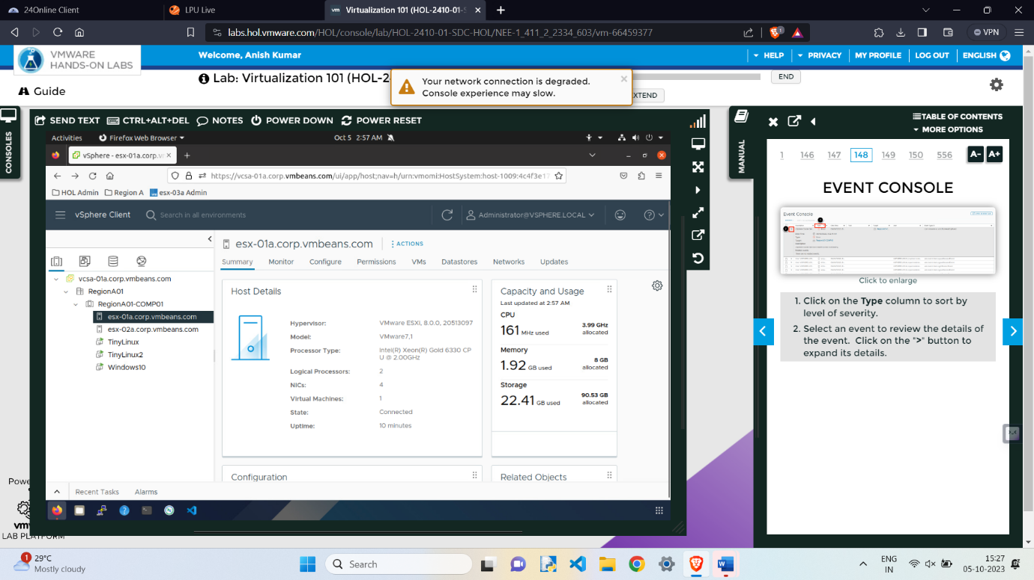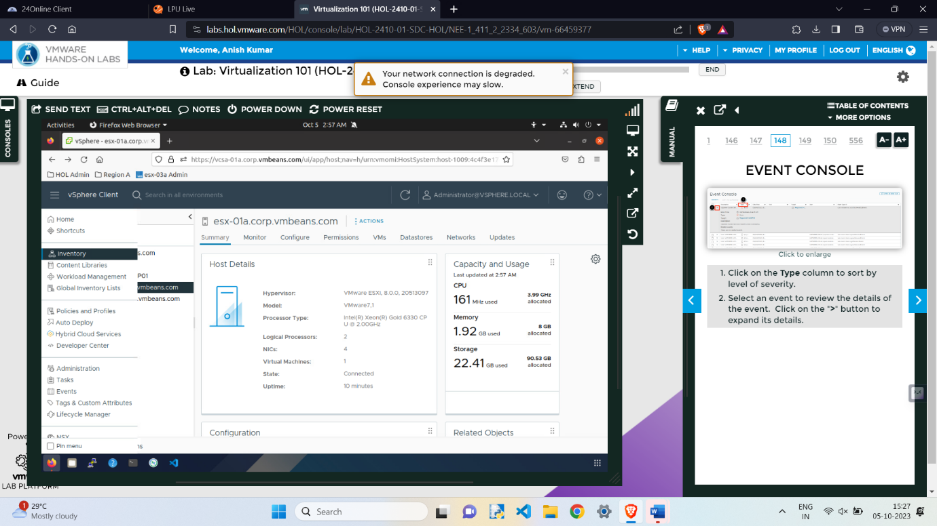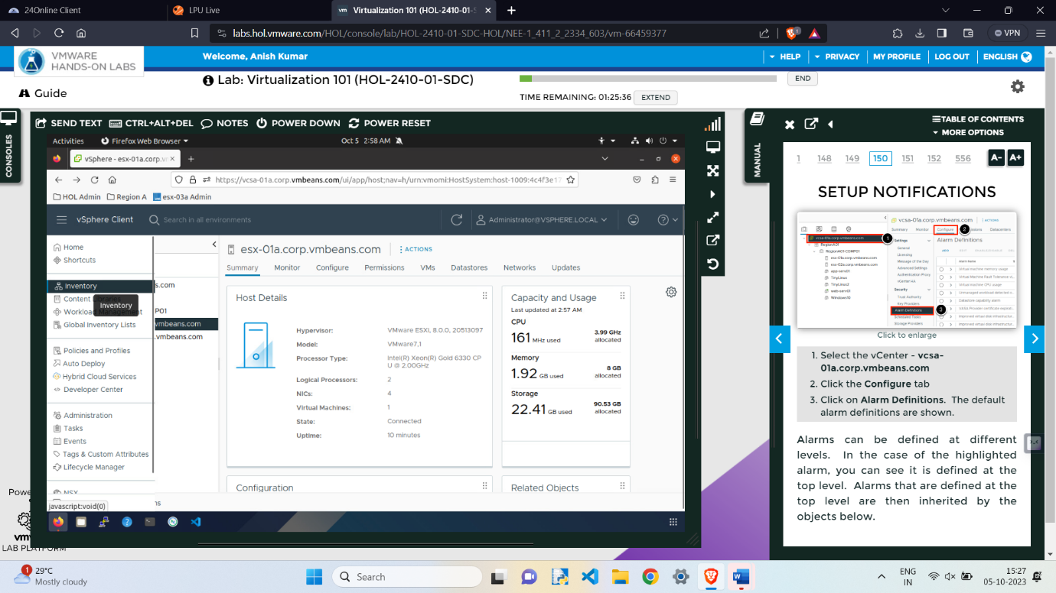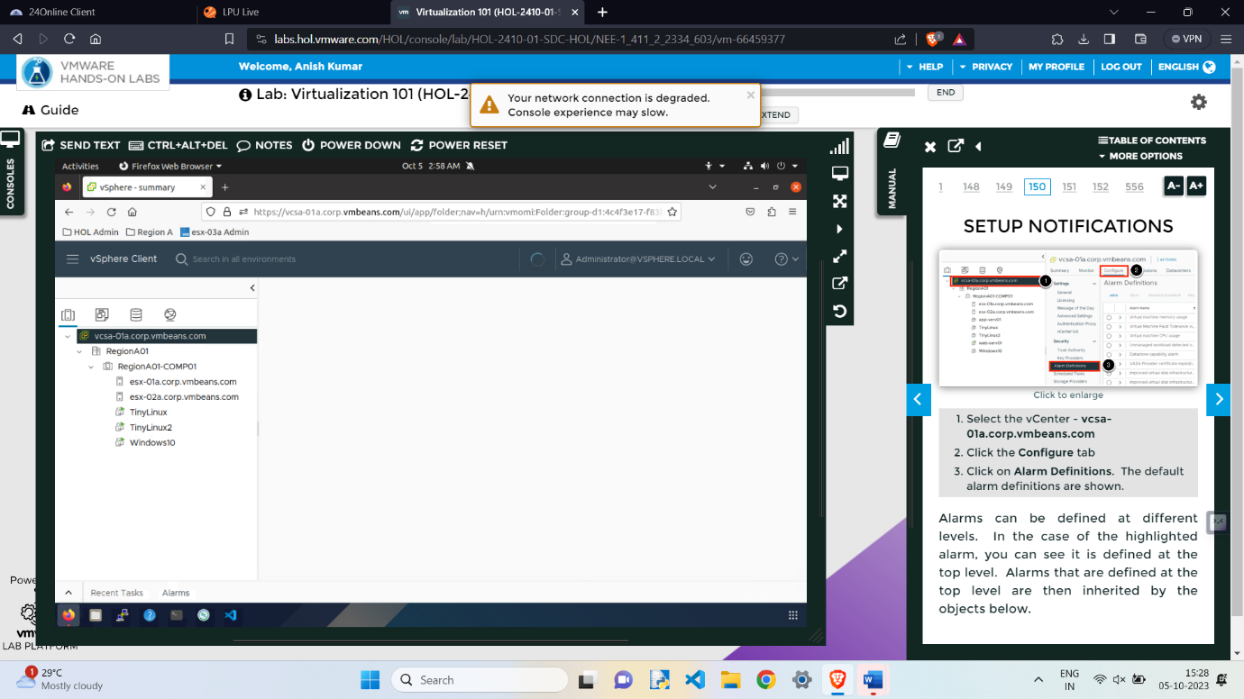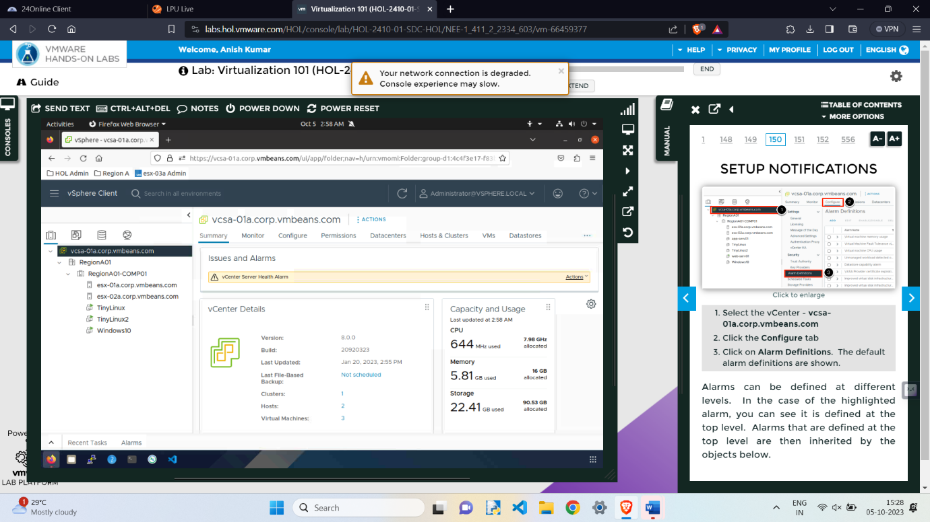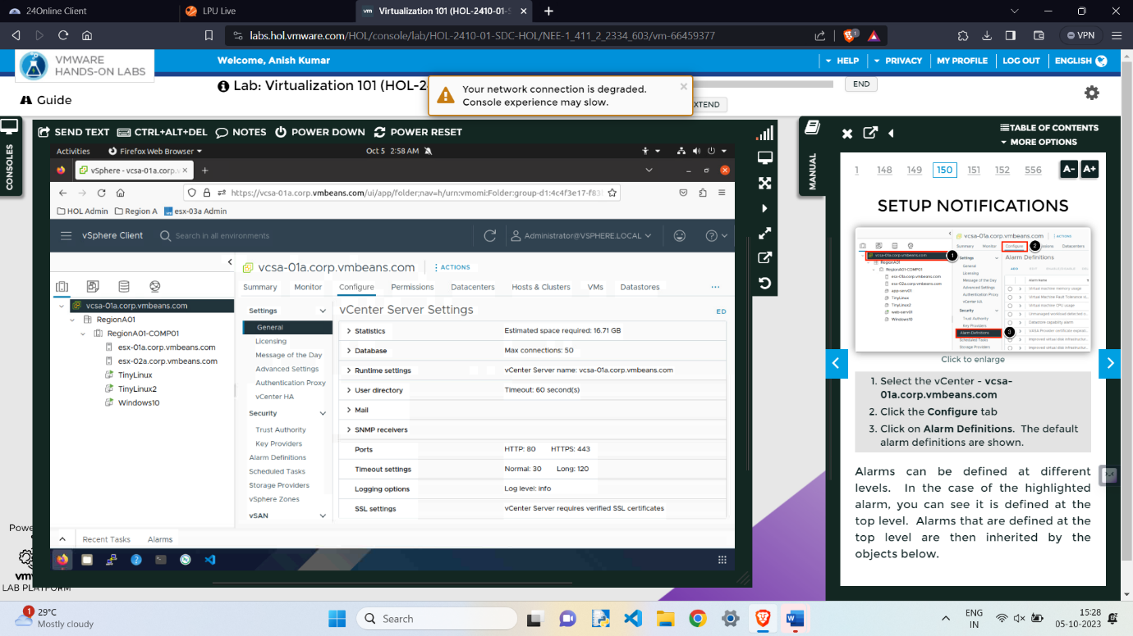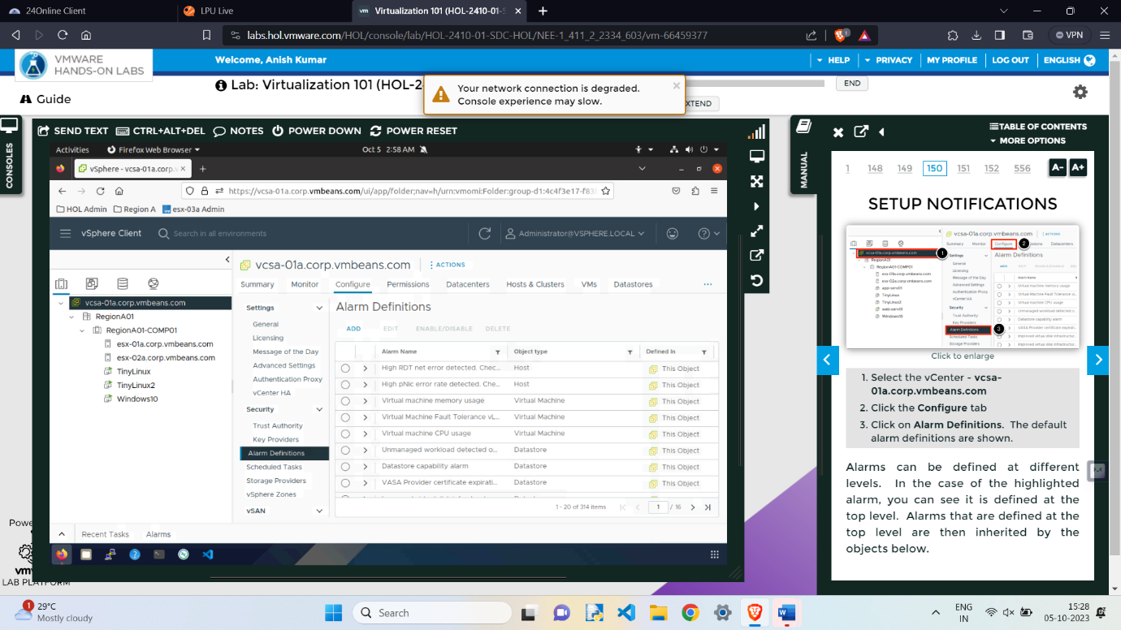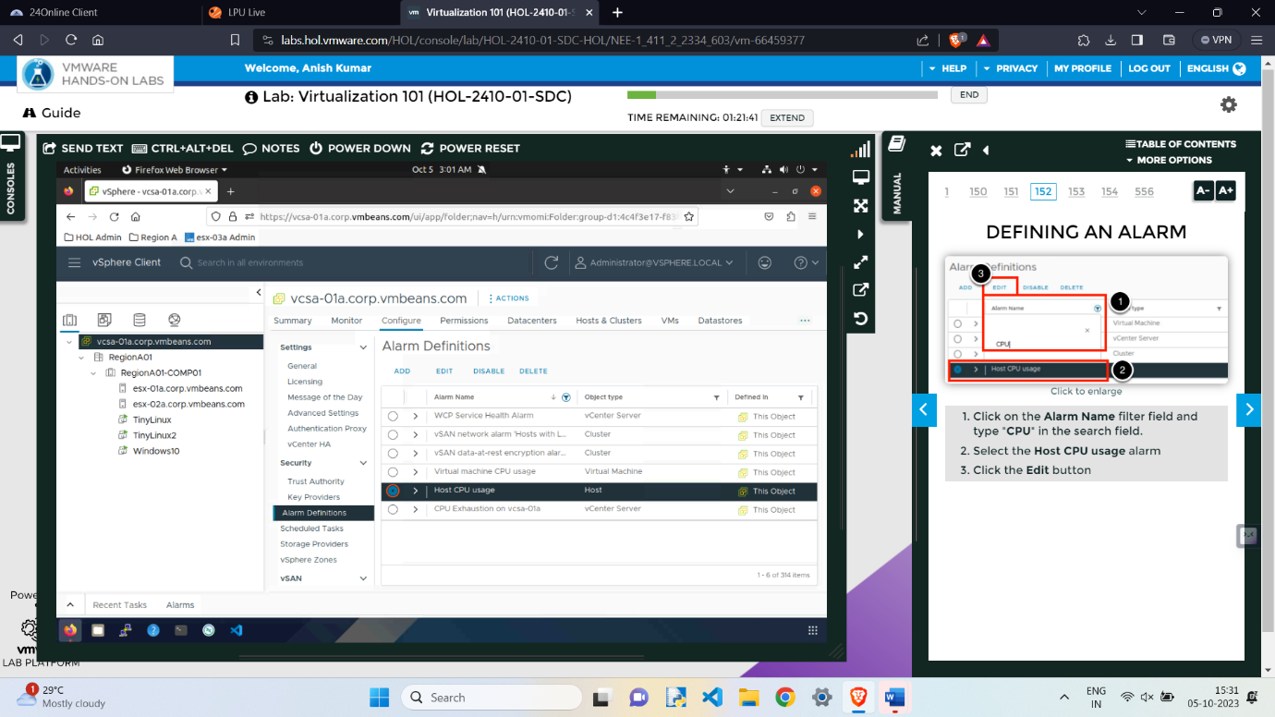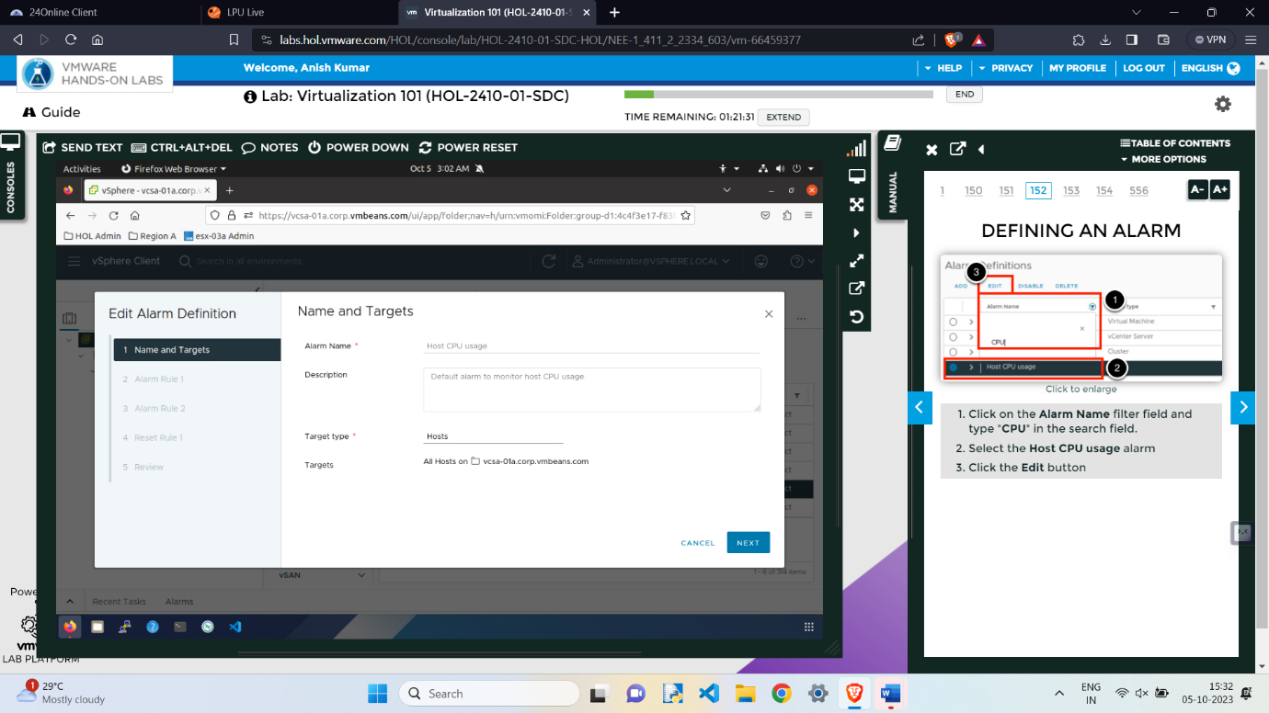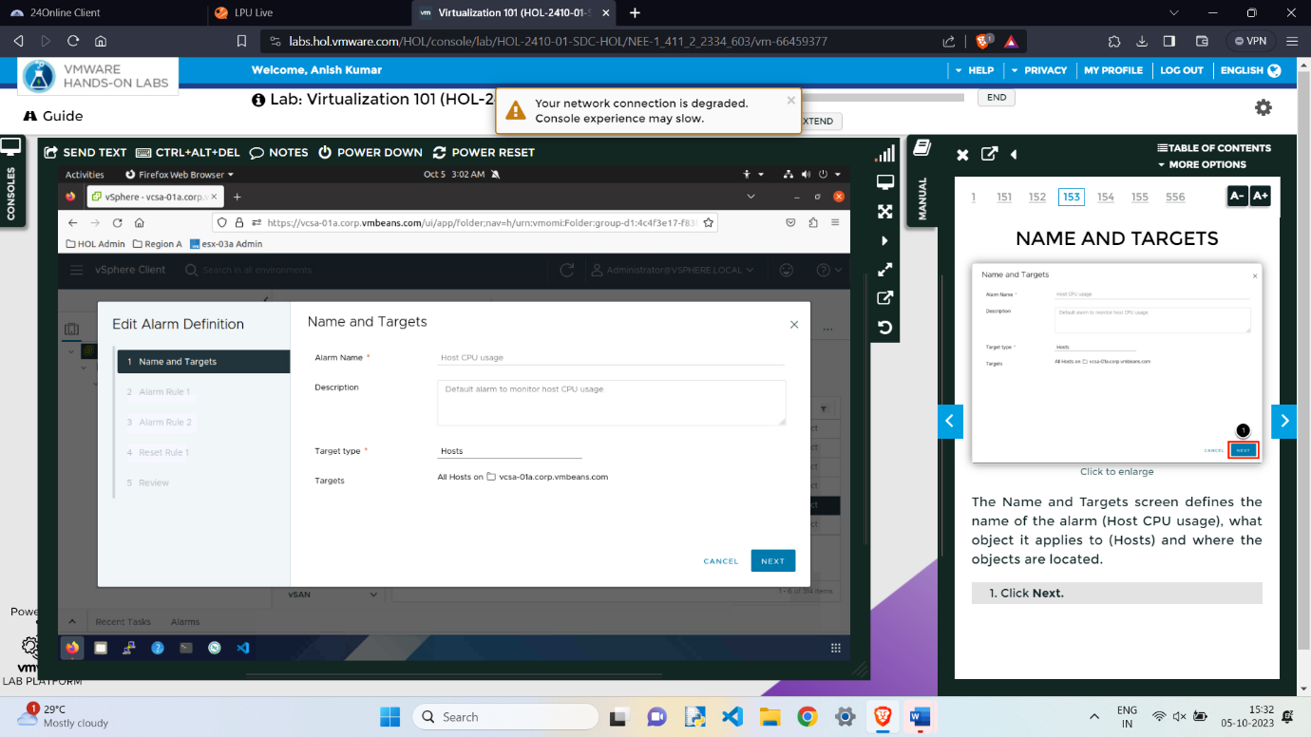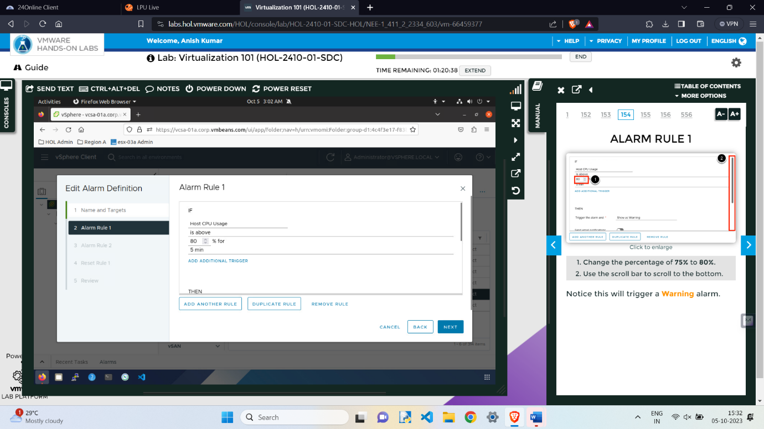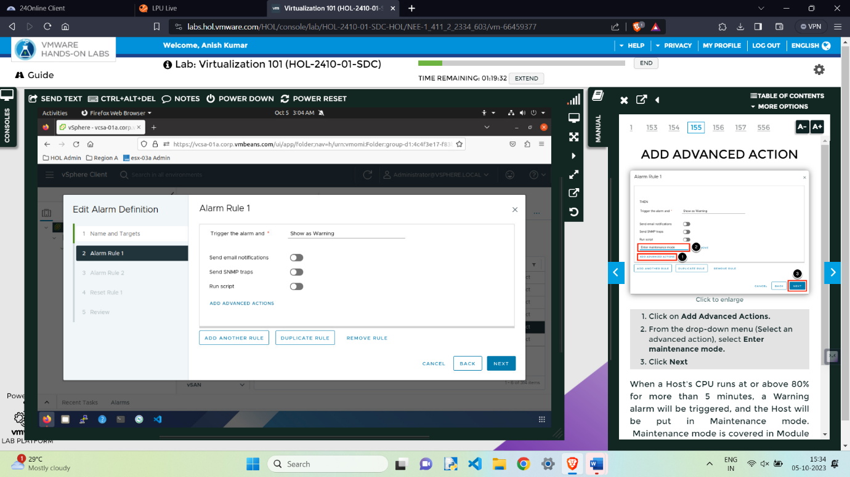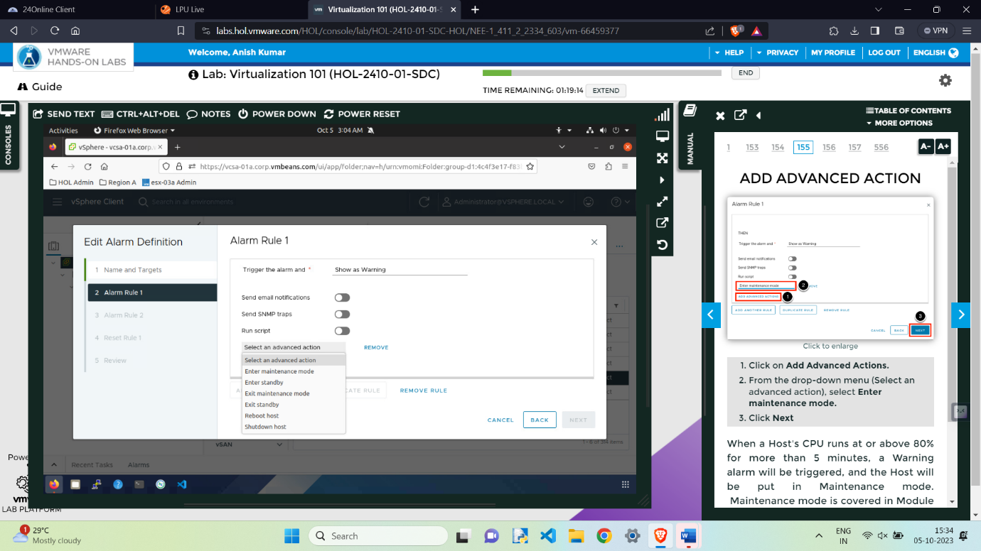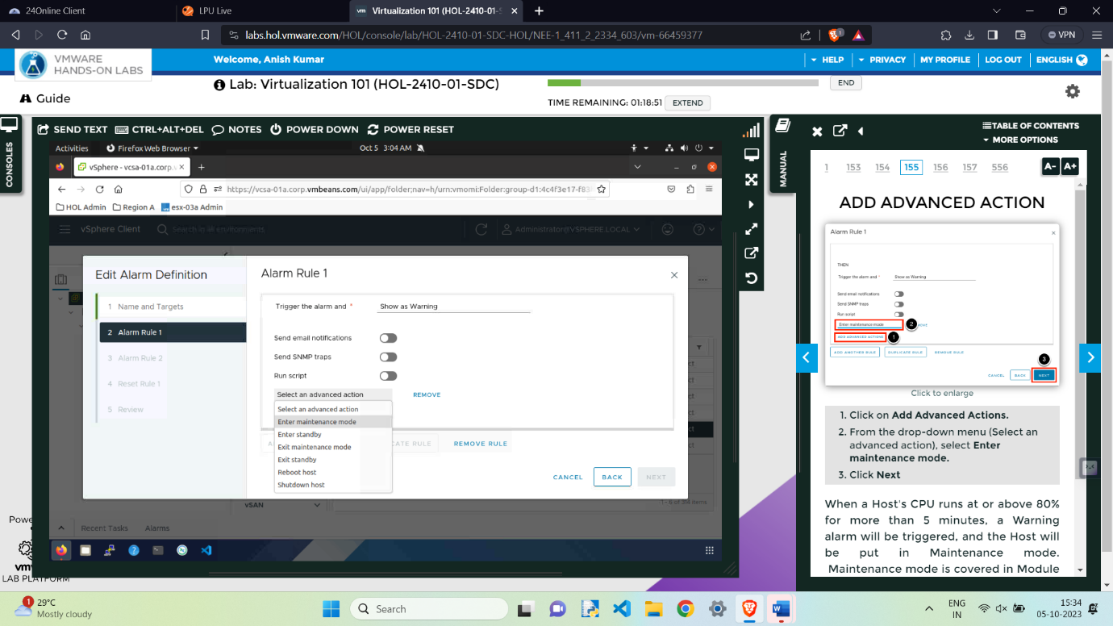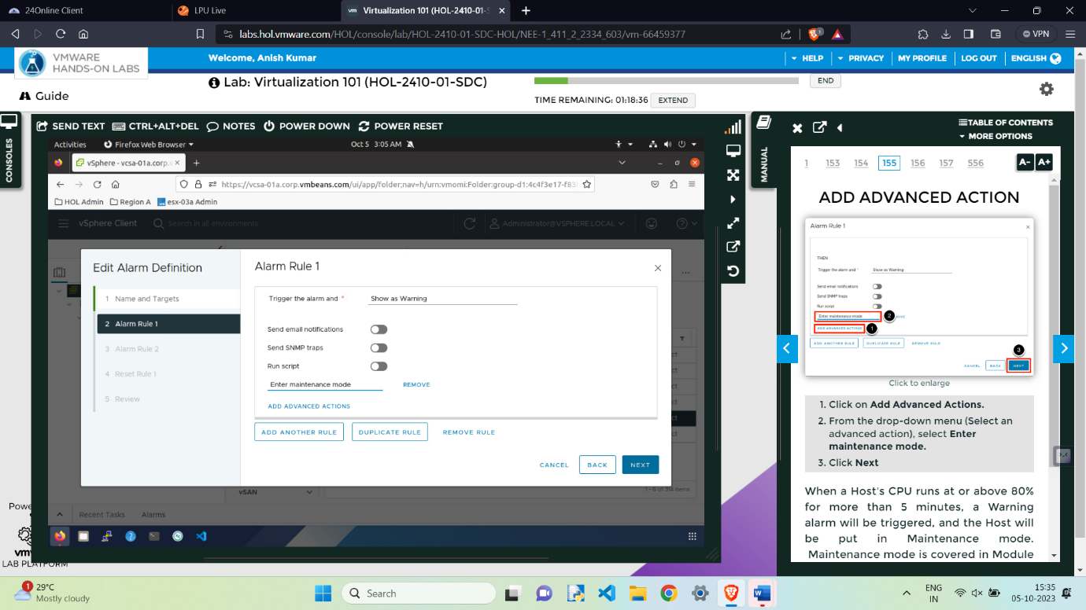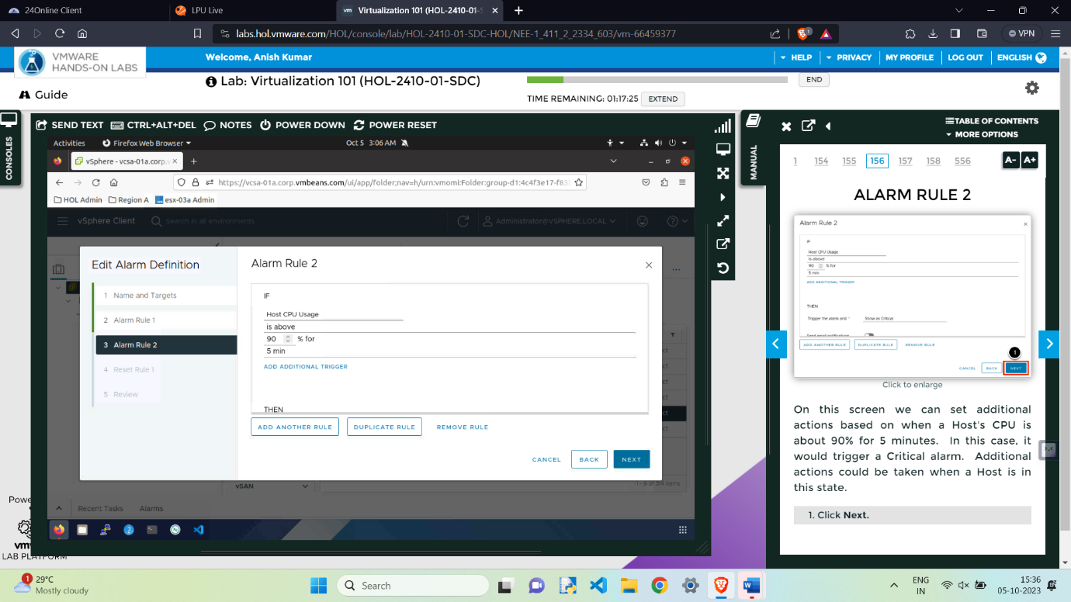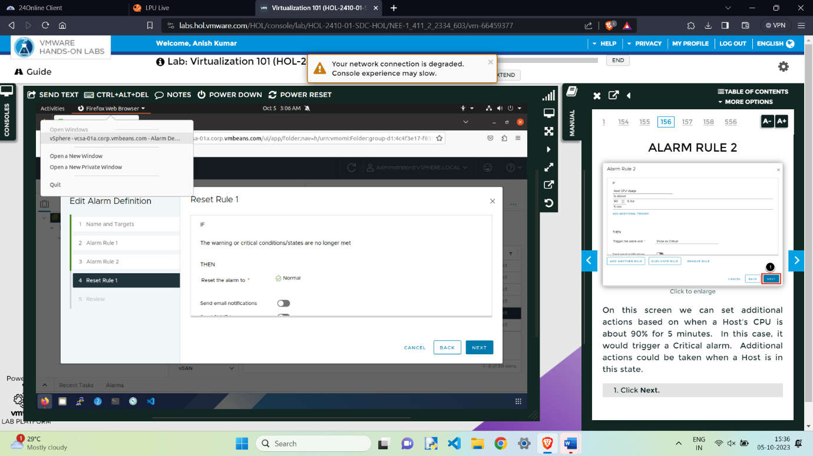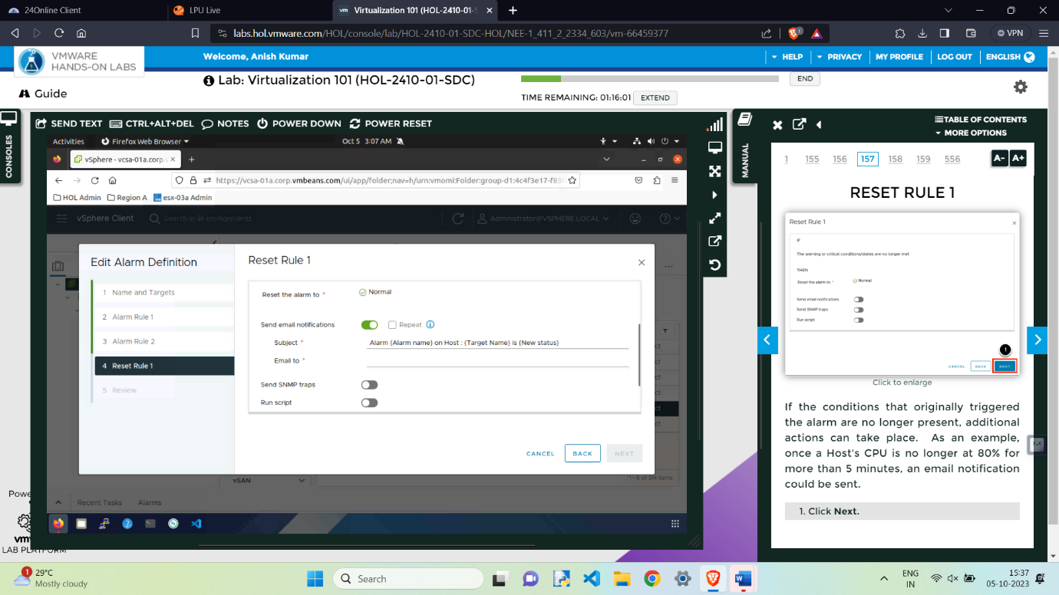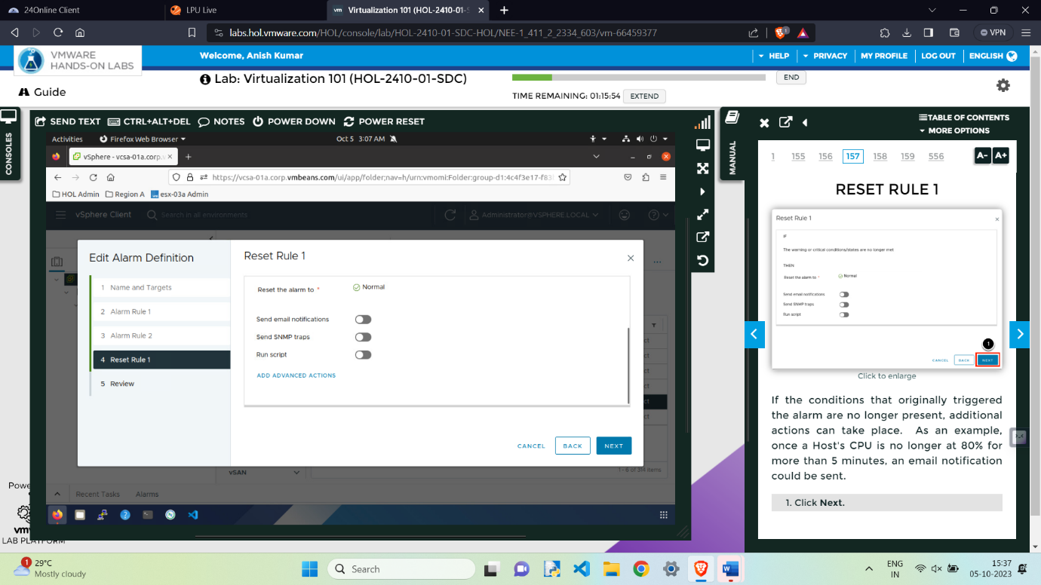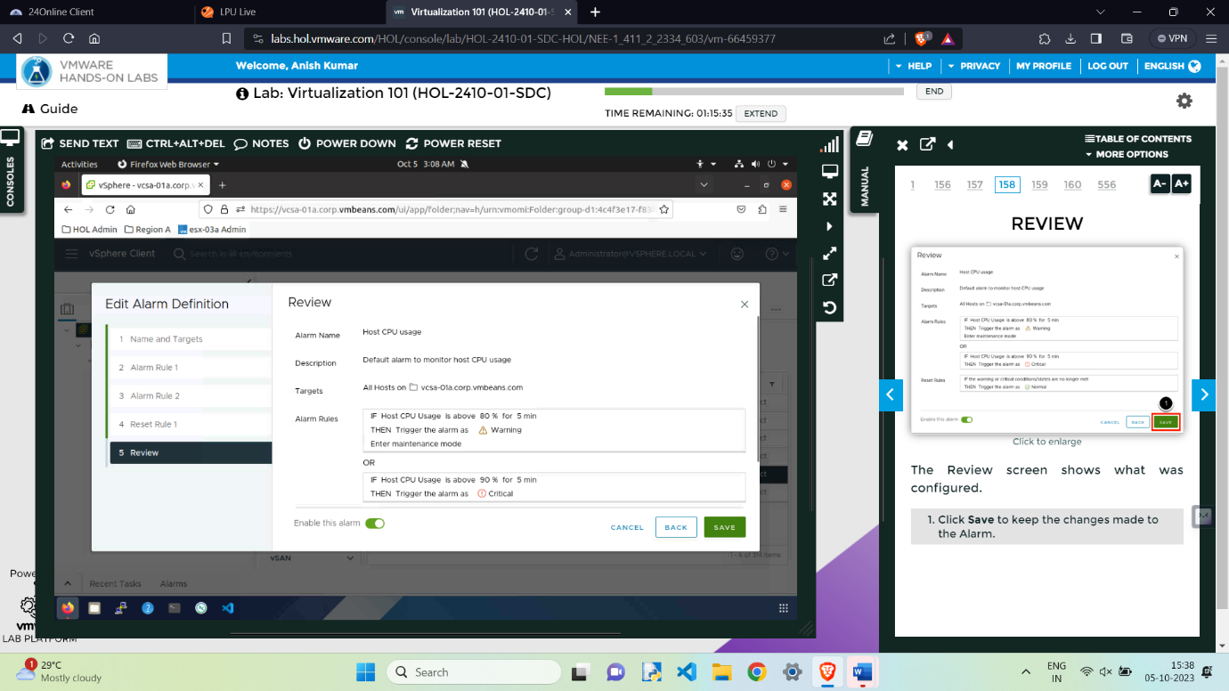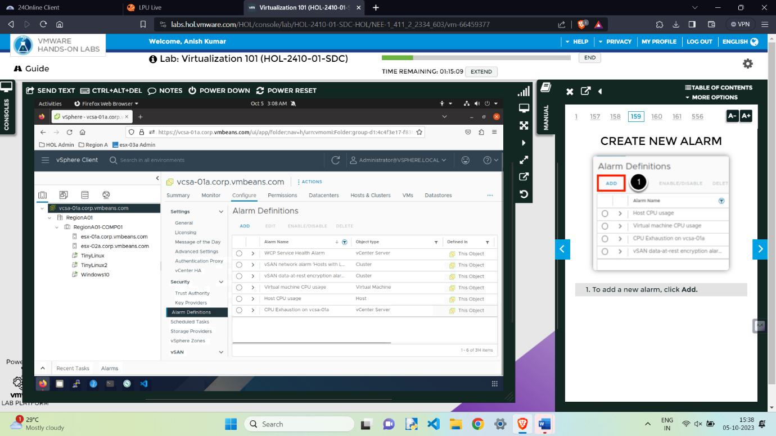

Alarm Listed in the List.

**Create New Alarm**

1. To add a new alarm, click Add
2. Enter Virtual Machine CPU Ready for the Alarm name.
3. .Change Monitor from vCenter Server to Virtual Machines.
4. Click Next to move to the Alarm Rule 1 screen
5. Click in the field under IF and select VM CPU Ready Time.

6.Change the select an operator filed to is above.

7.Type 8000 in the ms field

8.Use the drop-down menu to select 5 min.

8.Select Show as Warning in the Trigger the alarm menu.

9.Use the scroll bar to scroll to the Add advanced actions section

10.Click on Add Advanced Actions

11.From the drop-down menu, select Shutdown guest on VM.

This will gracefully shutdown the virtual machine rather than just powering it off.

12.Click Next

13.Click Next

14. Click Create

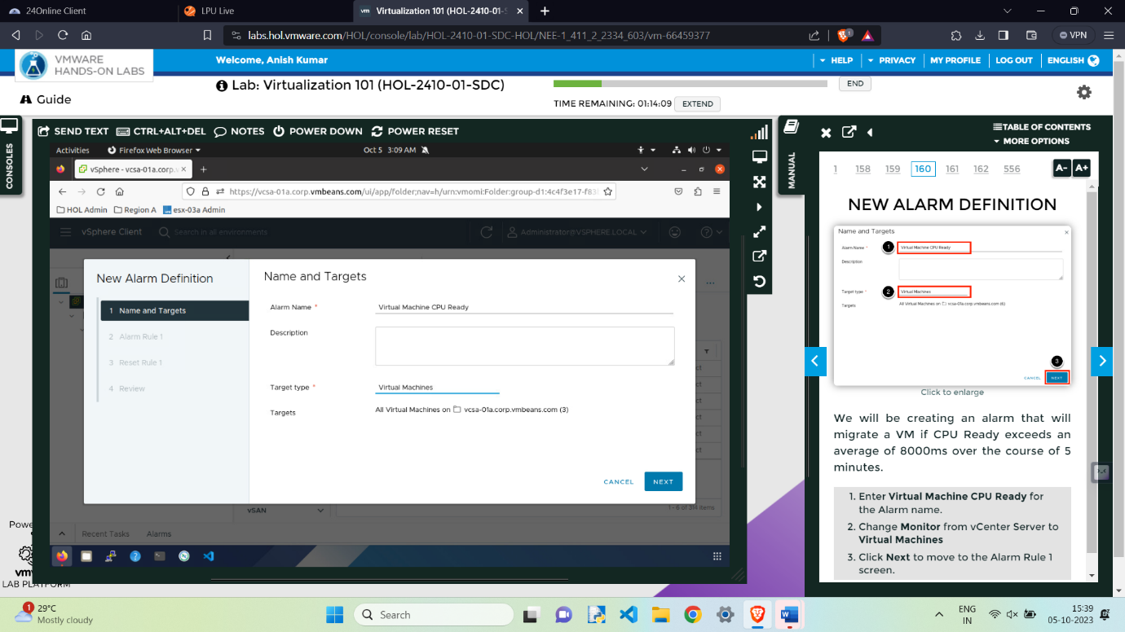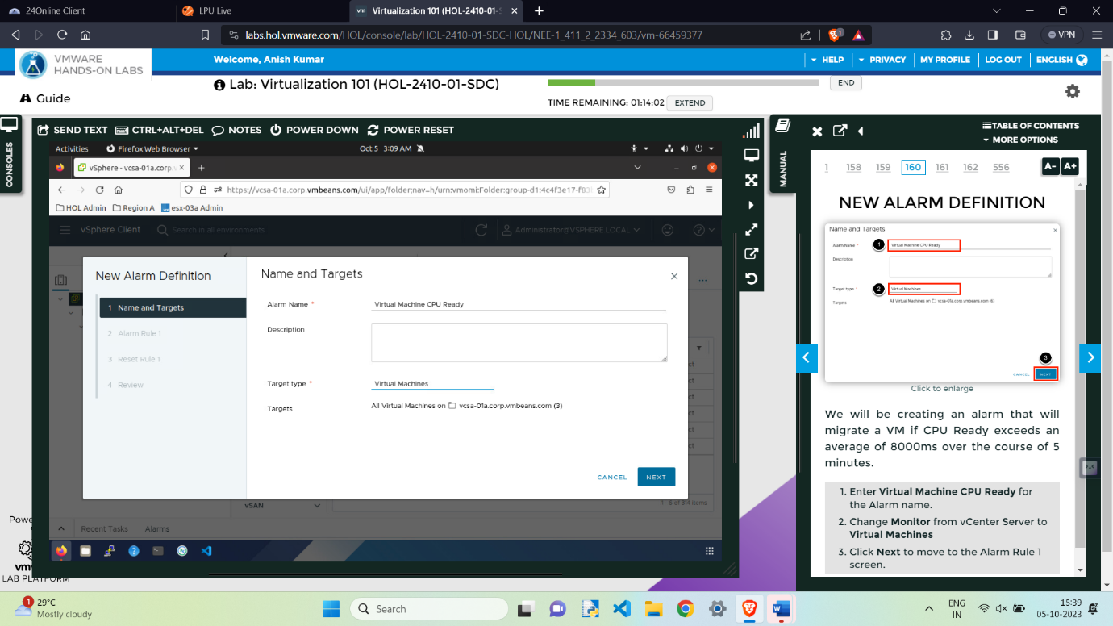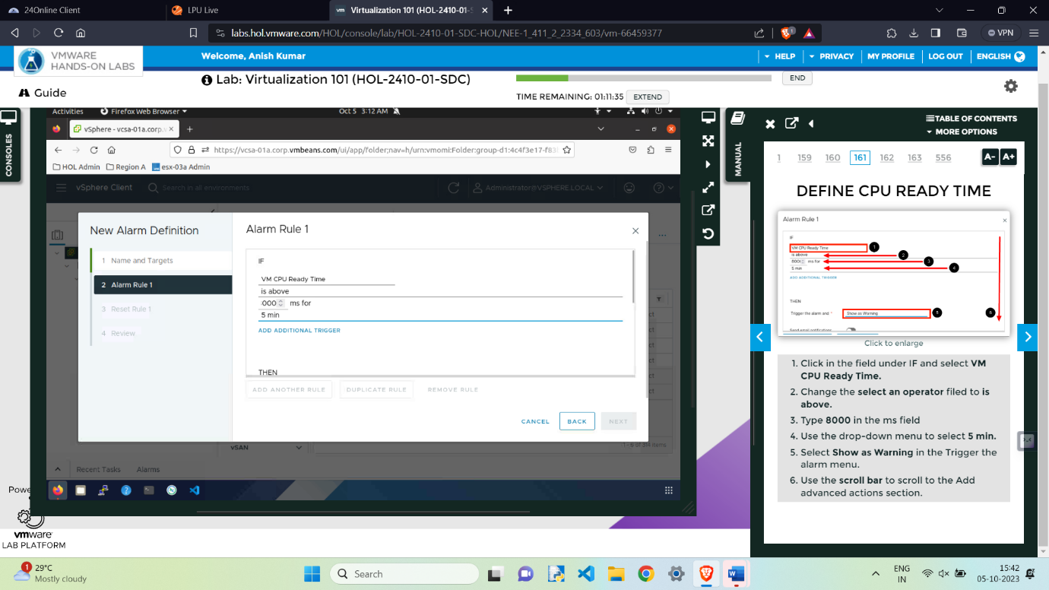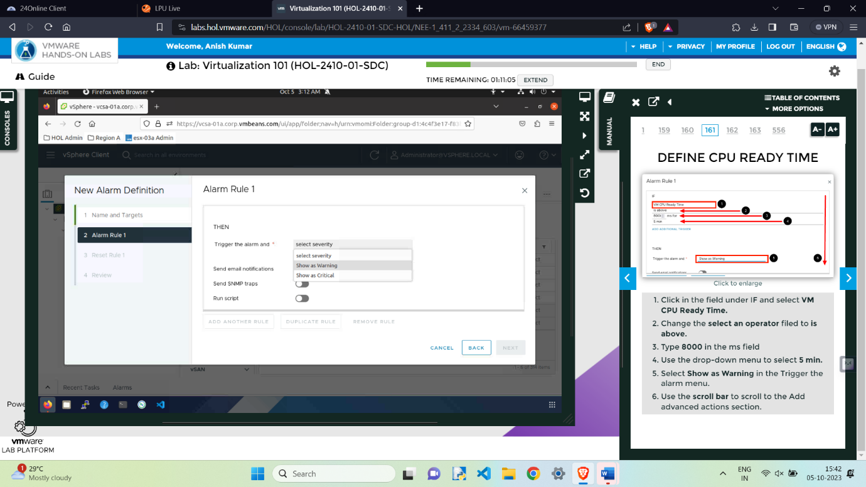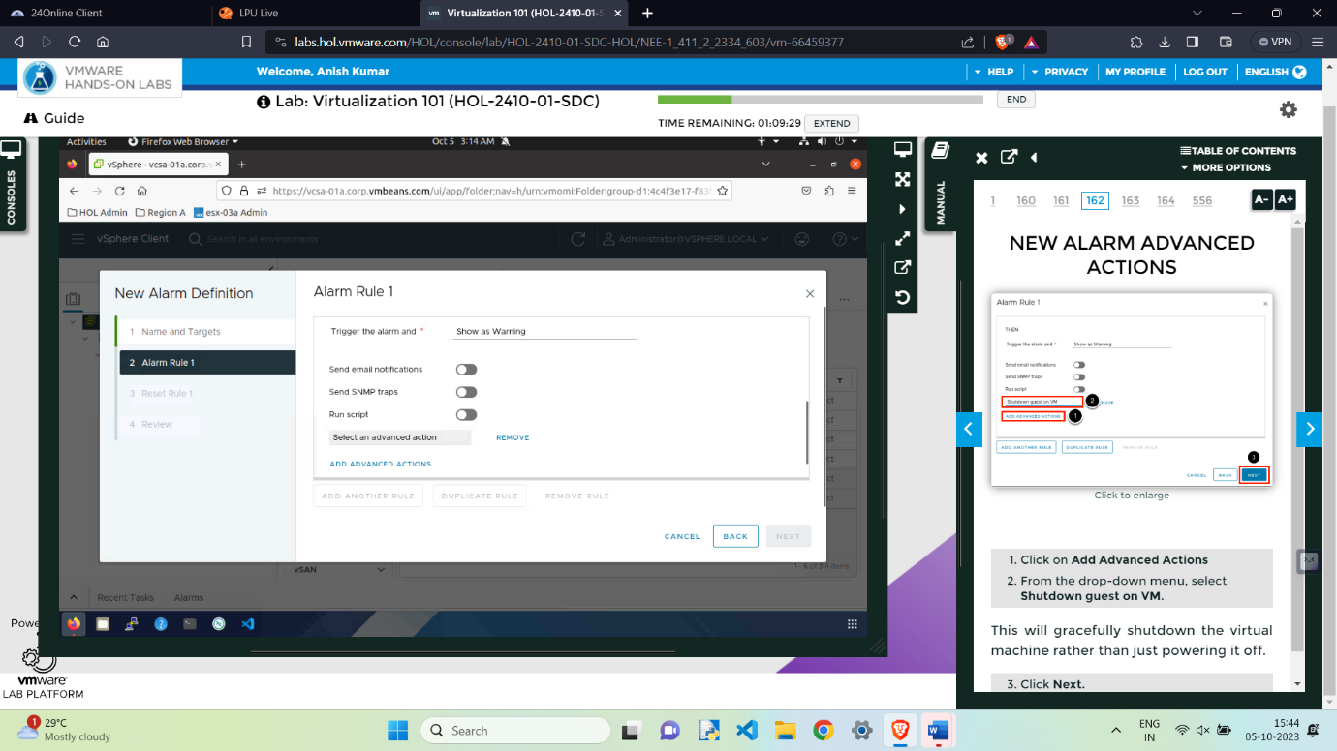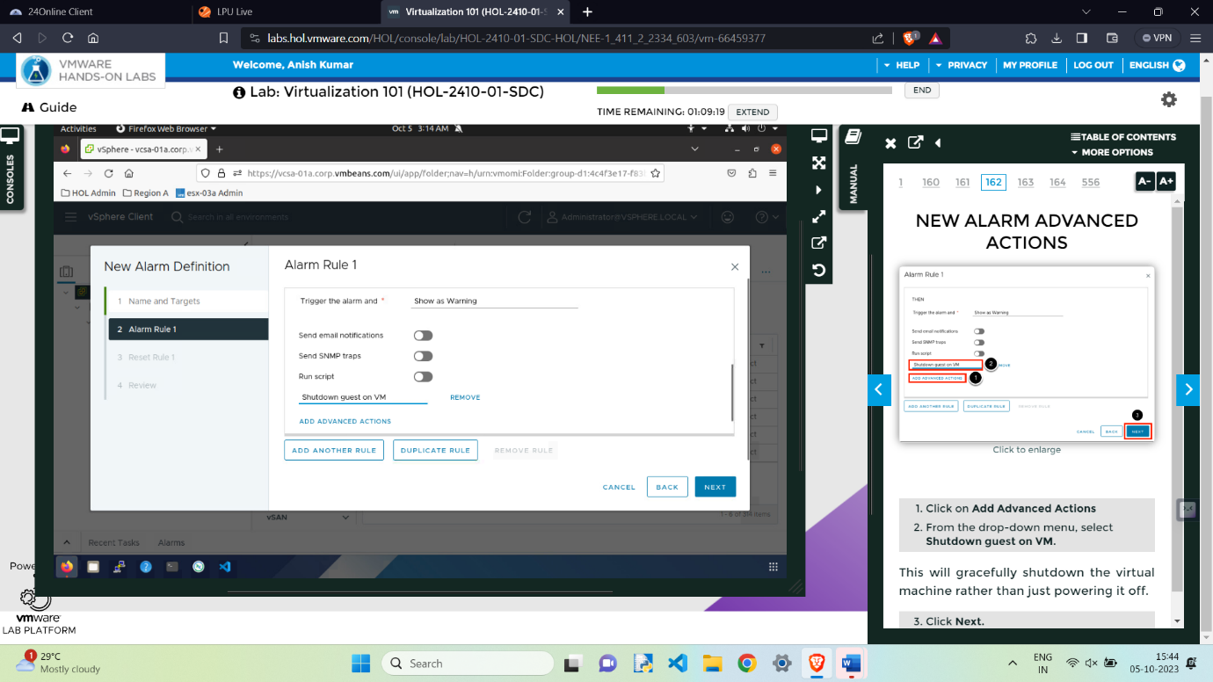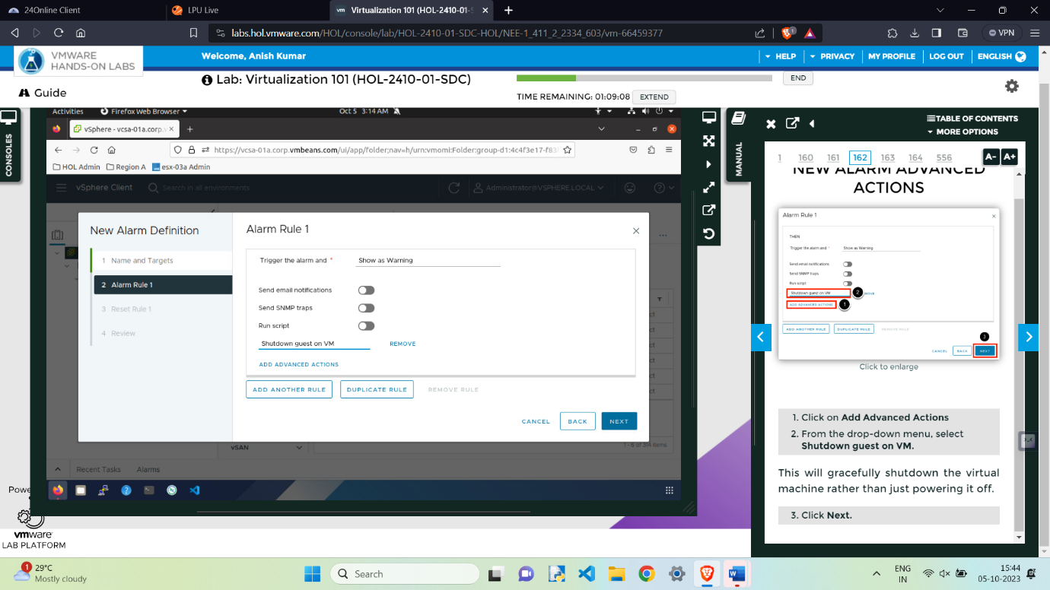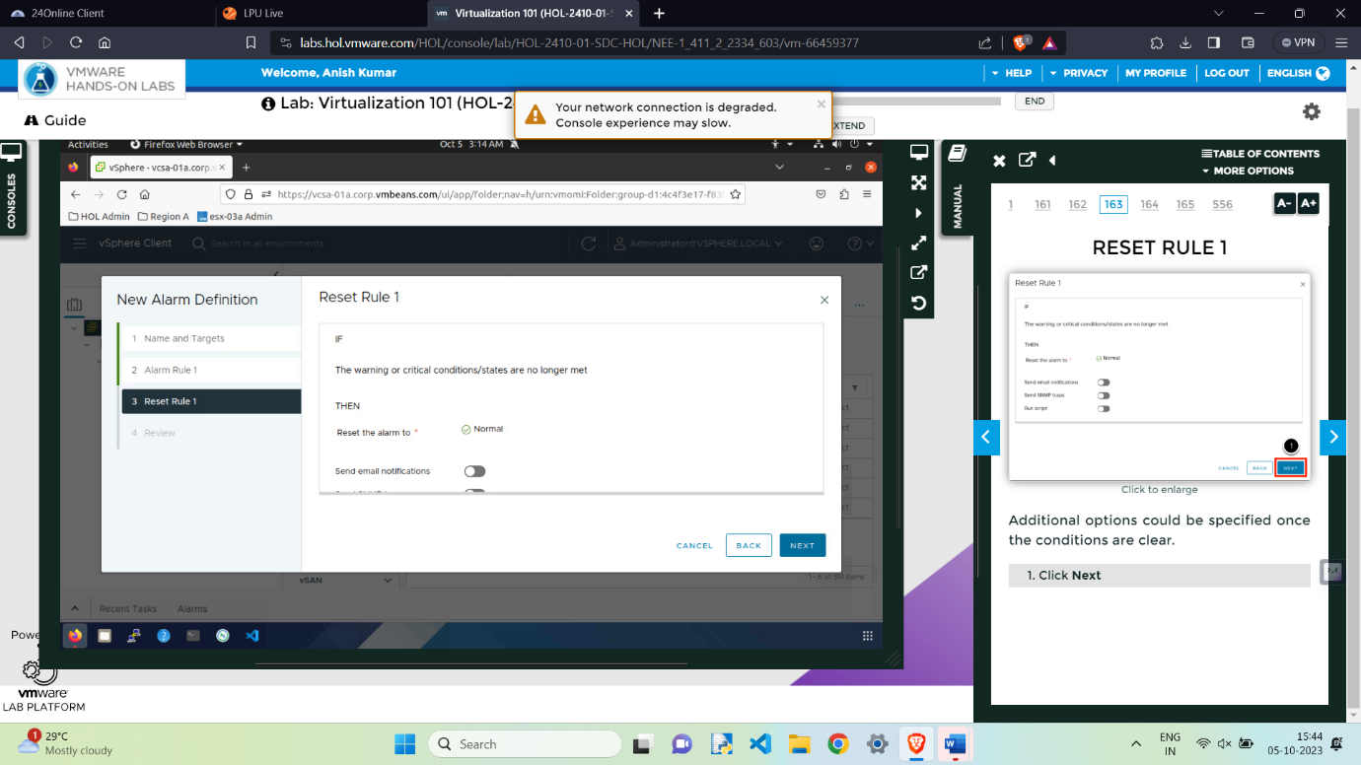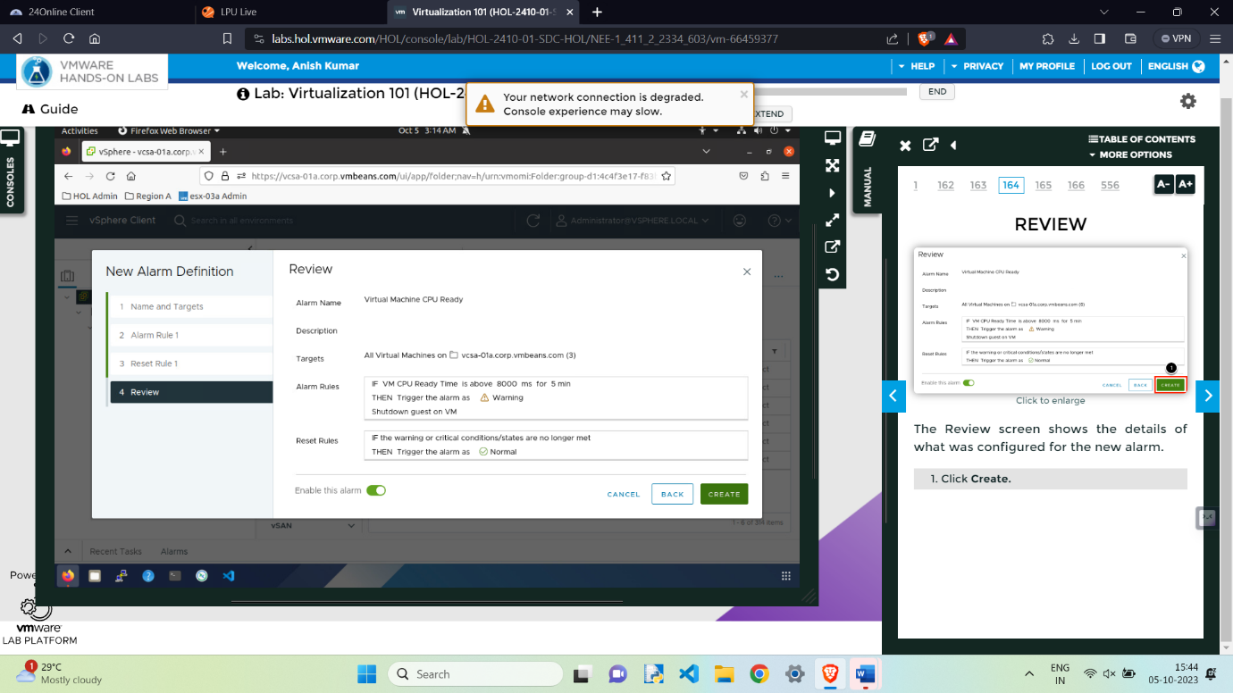

**New Alarm Created**

**Testing that if alarm works or not:**

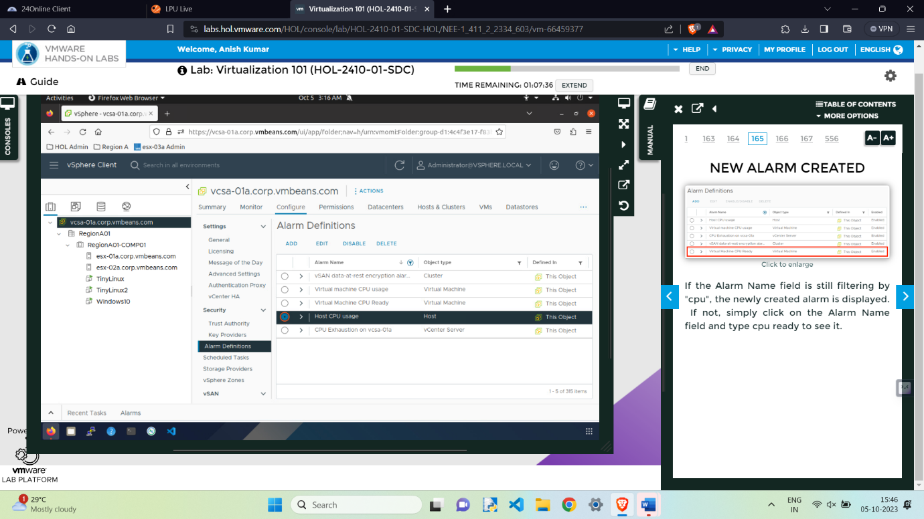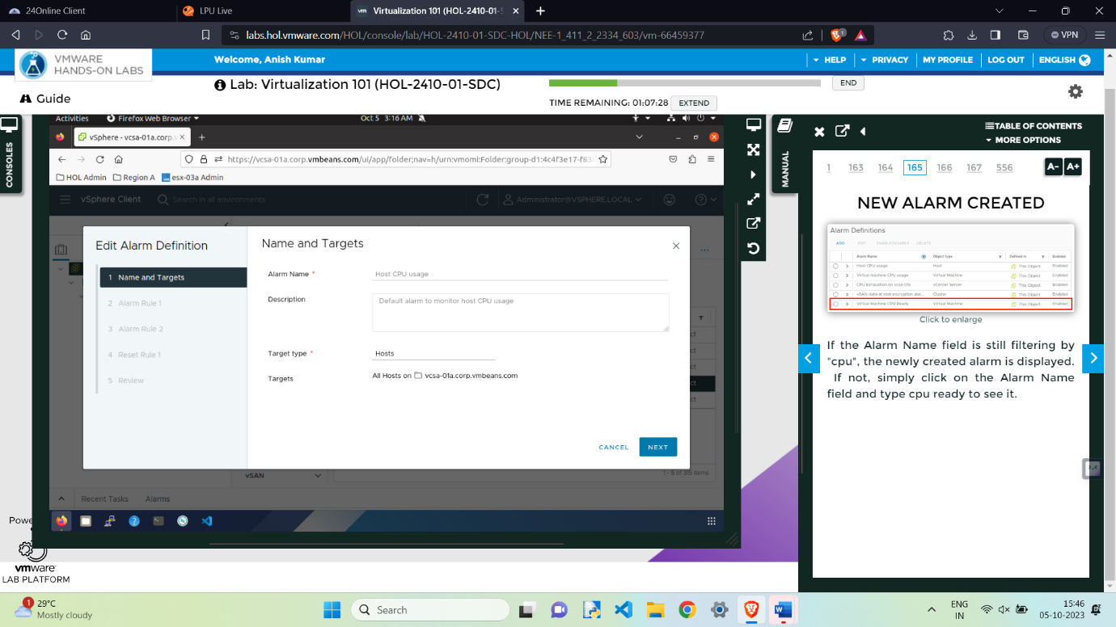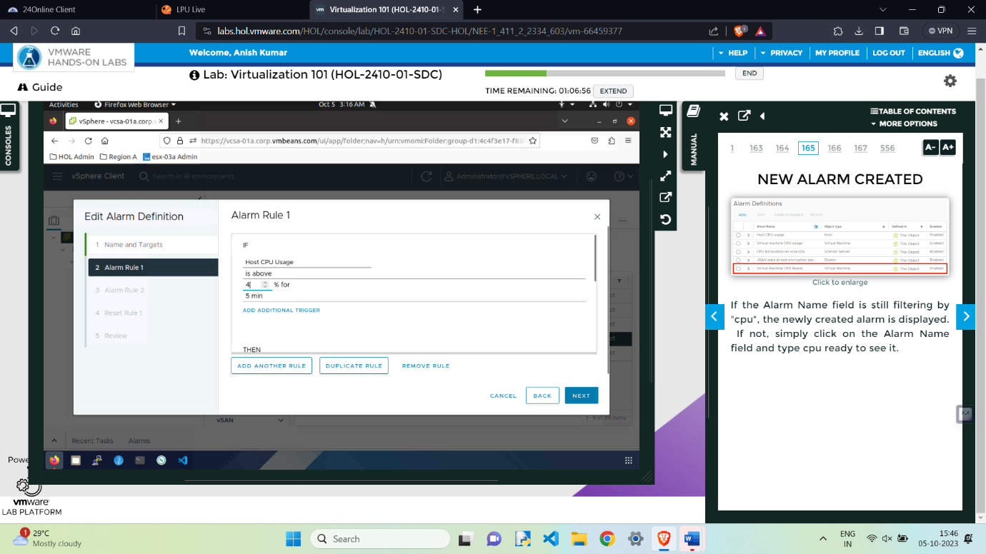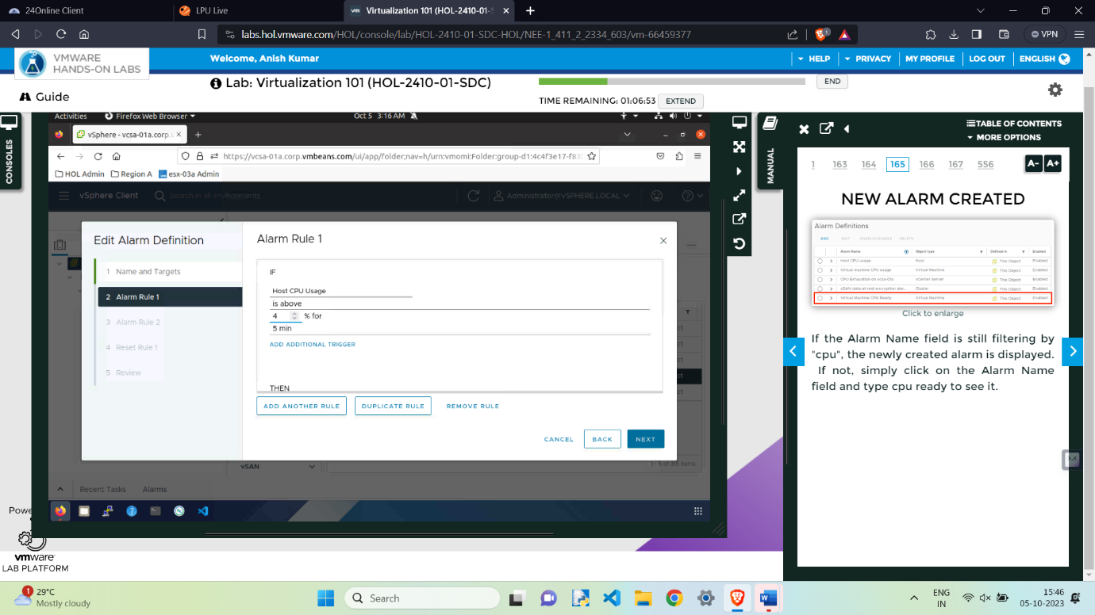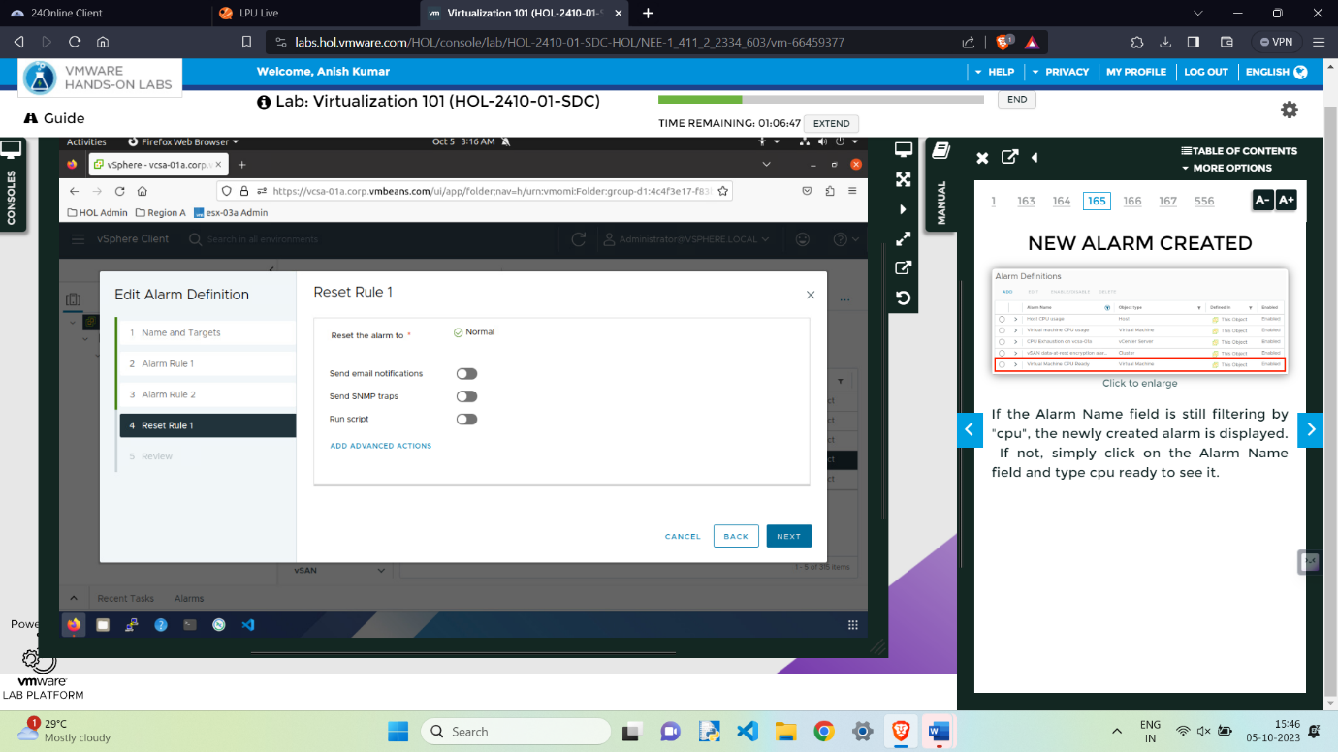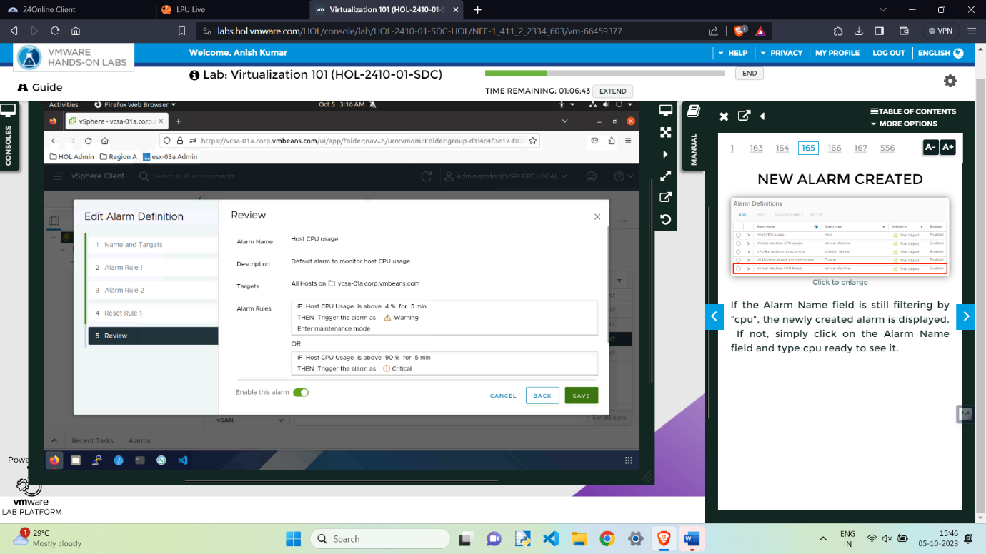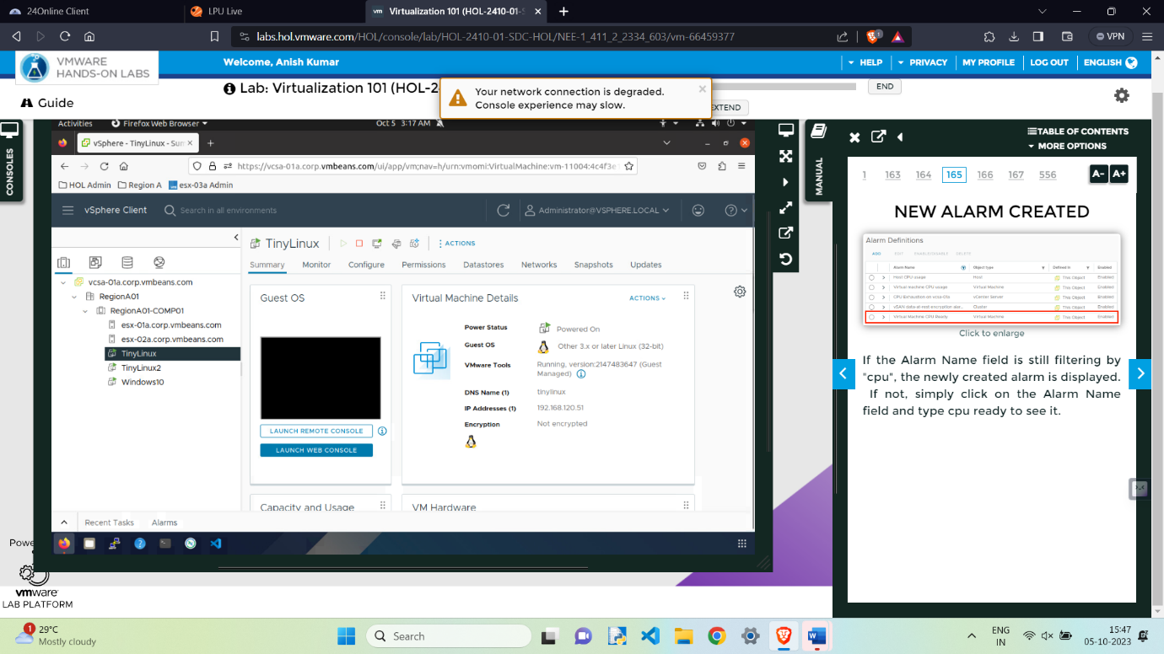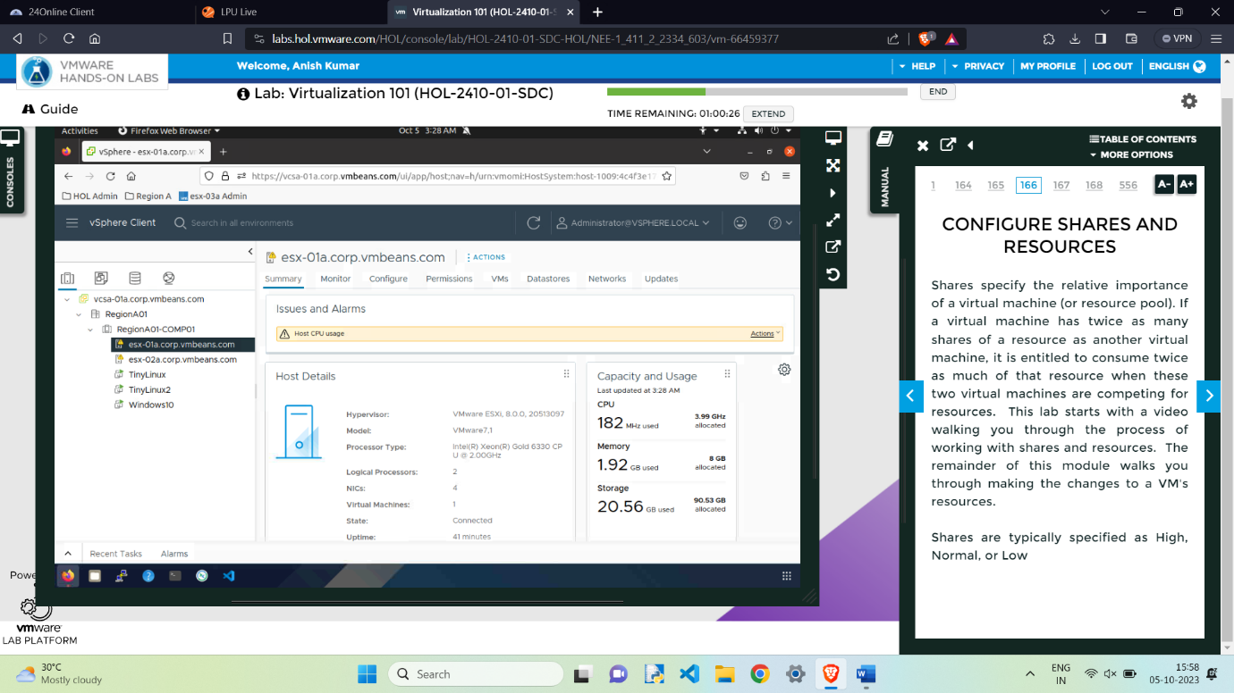

Pop-up came after meeting the condition set in the alarm.

Done.

**Tags and Custom Attributes**

Click Menu on the top left corner

2.Select "Tags and Custom Attributes.

3.Click the Categories tab.

4.Click New

5. Enter "web tier" for the Category Name.

6.For a description, type "All objects in the web tier."

7.Keep the default One tag tags per object

8.Click Create

9.Click the Tags tab to create a new a Tag.

10.Click New

11. Name the tag Web Server version 2

12.Leave the web tier category as is.

13.Select Create

14. The newly created tag has now been added.

In order for these tags to be useful, they need to be assigned to objects. In the next steps, the tag will be assigned to virtual machines.

15.Click into the Menu on the top left corner

16.Select Inventory

17. Select the Virtual Machines and Templates tab

18.Right-click the virtual machine web-serv01.

19.Find Tags & Custom Attributes

20.Click Assign Tag...

21. Click the Web Server version 2 tag.

22.Click Assign.

23. In the Search field enter "we".

24.Select the Tag Web Server version 2.

Click on the Objects tab to find the list of objects which have been assigned the Web-serv01 tag.

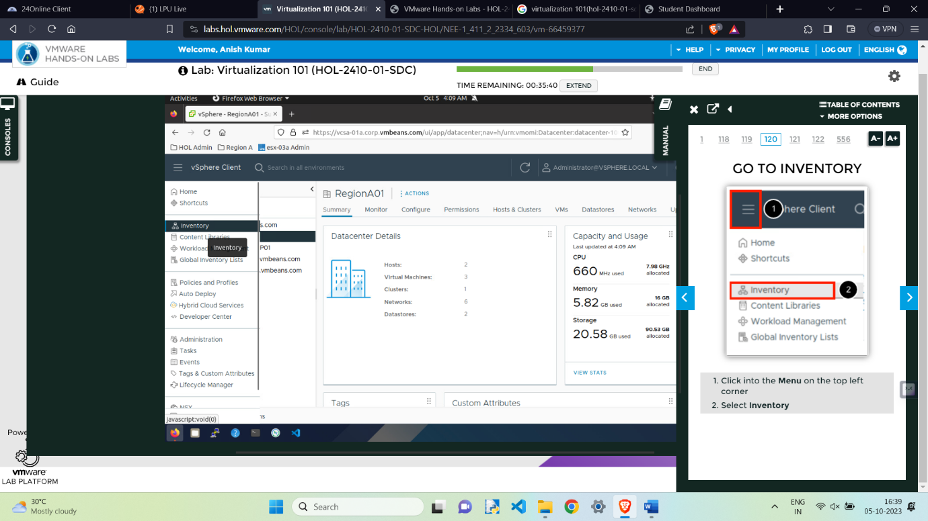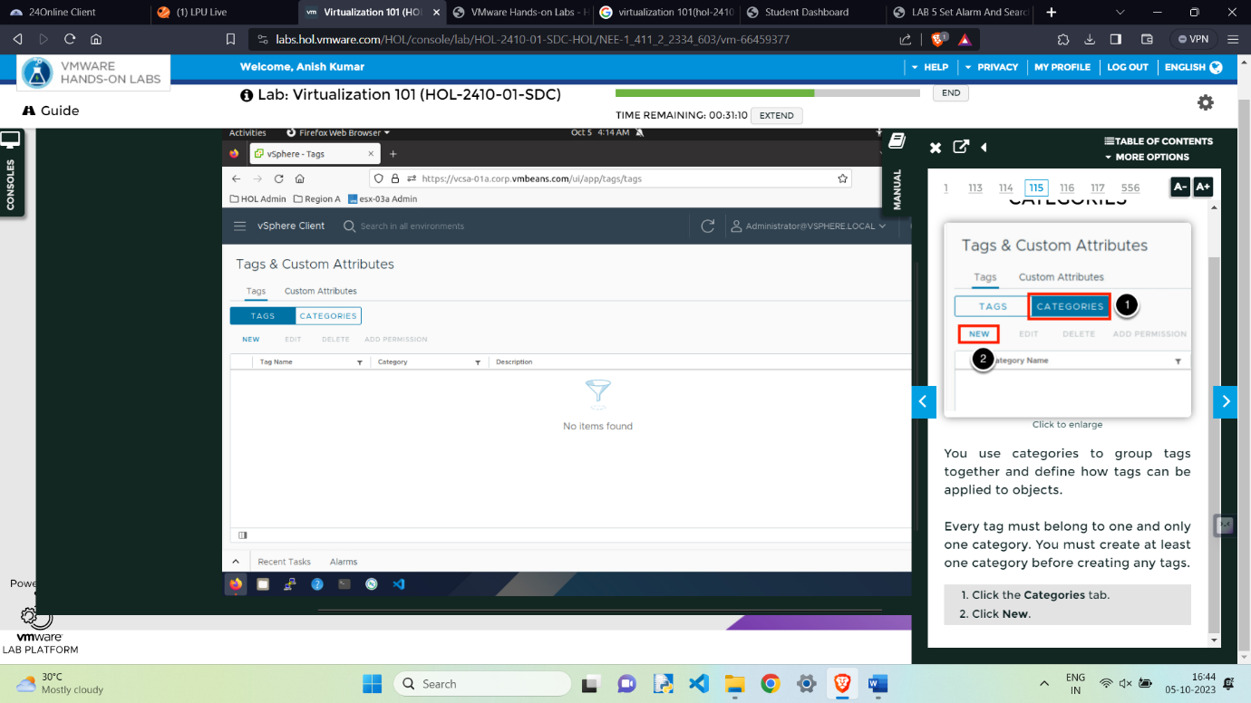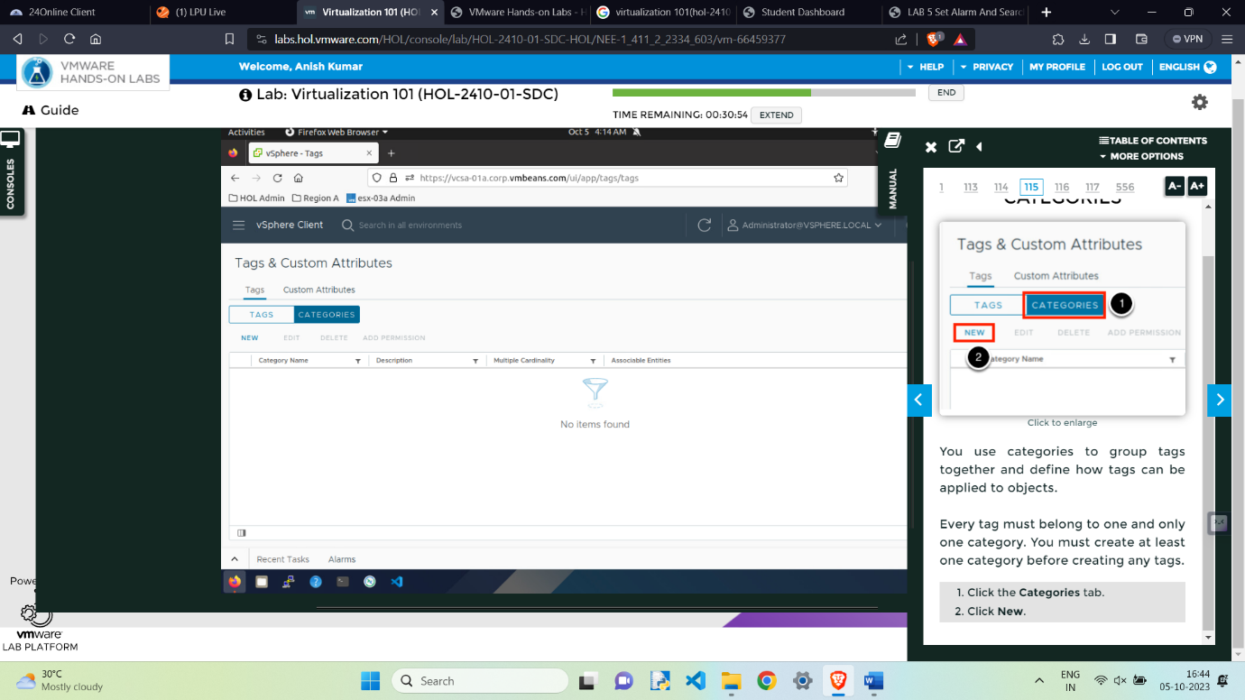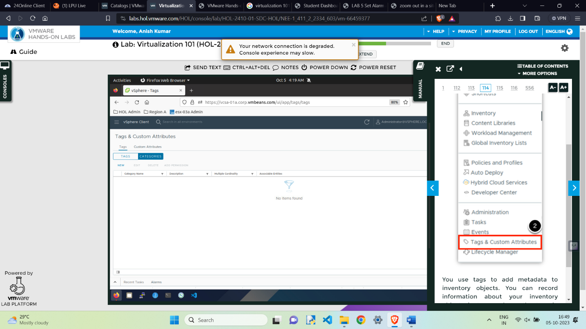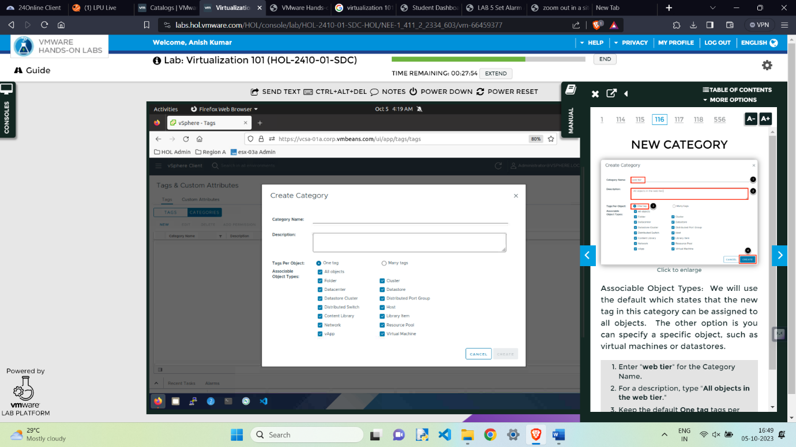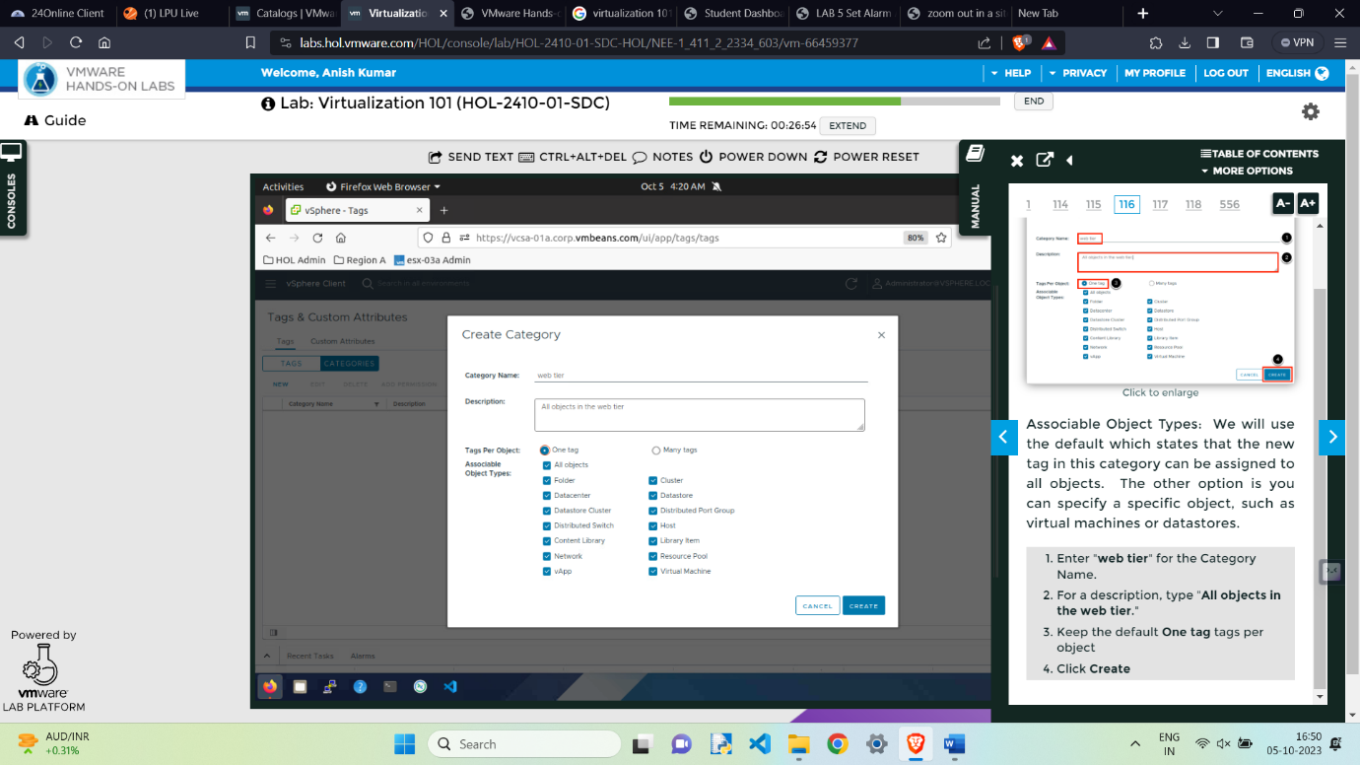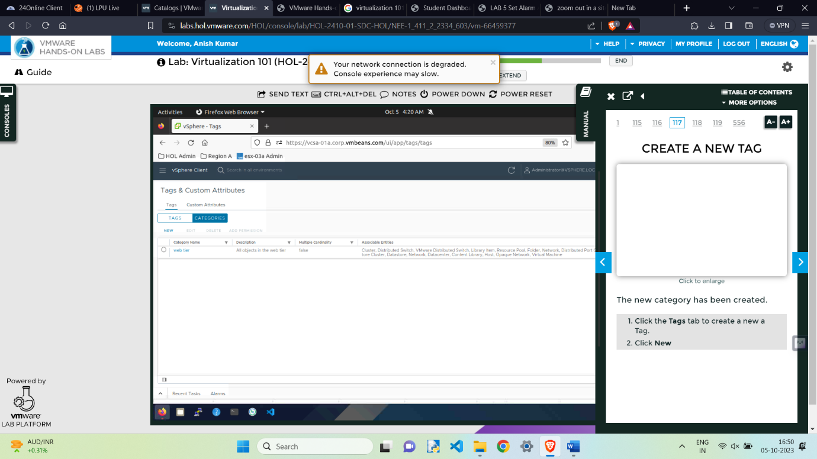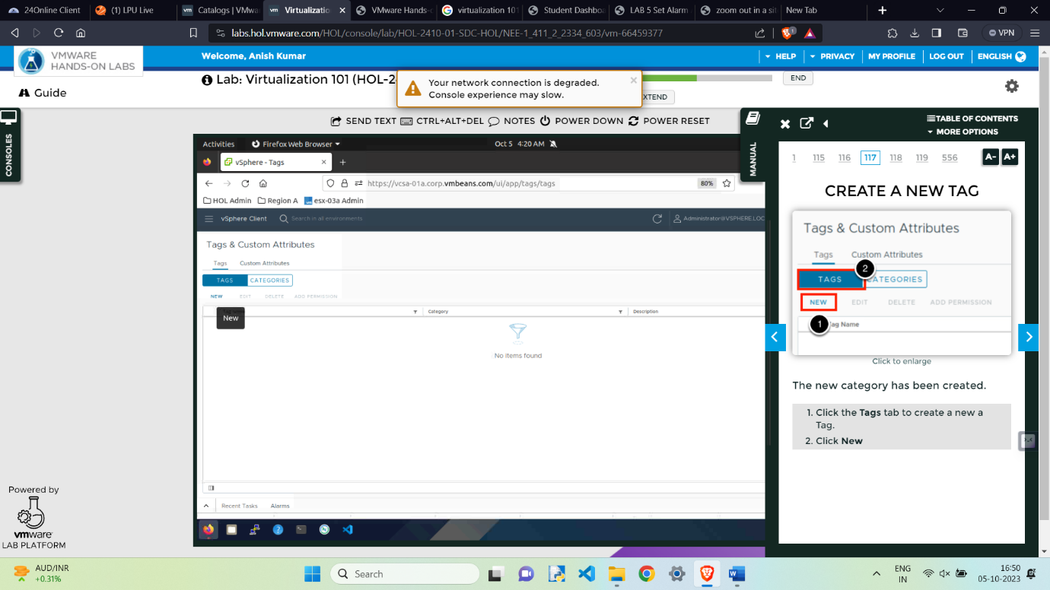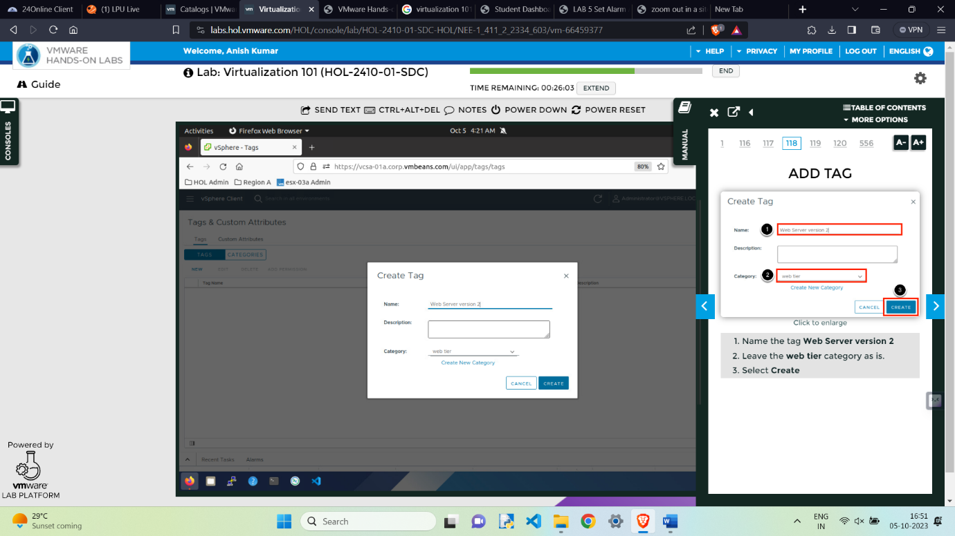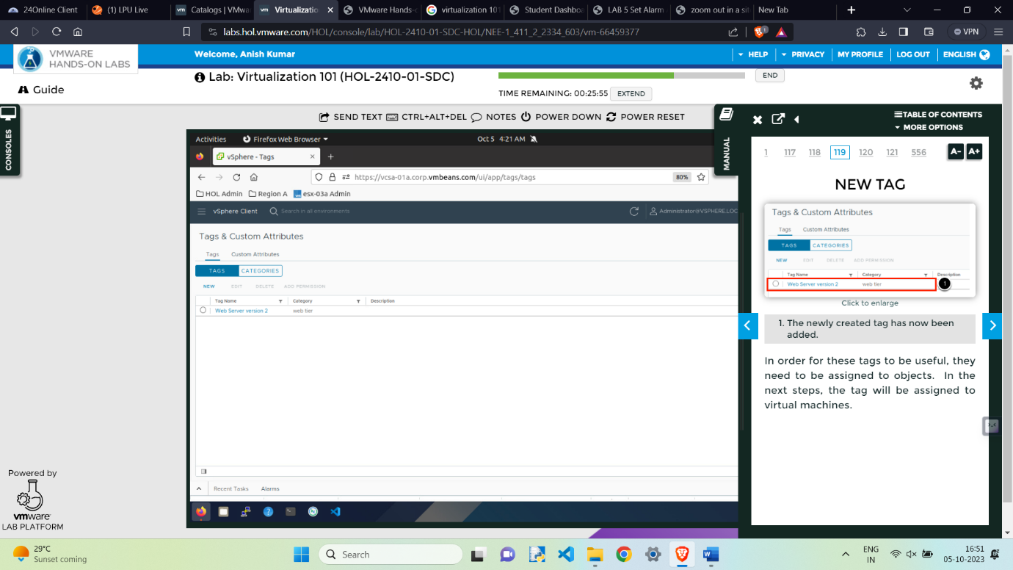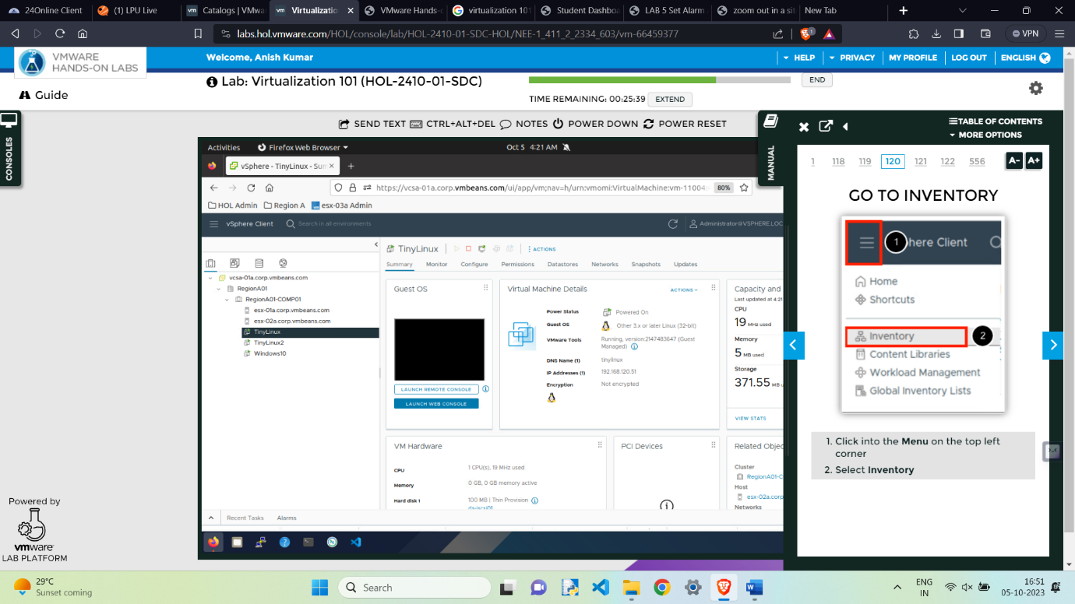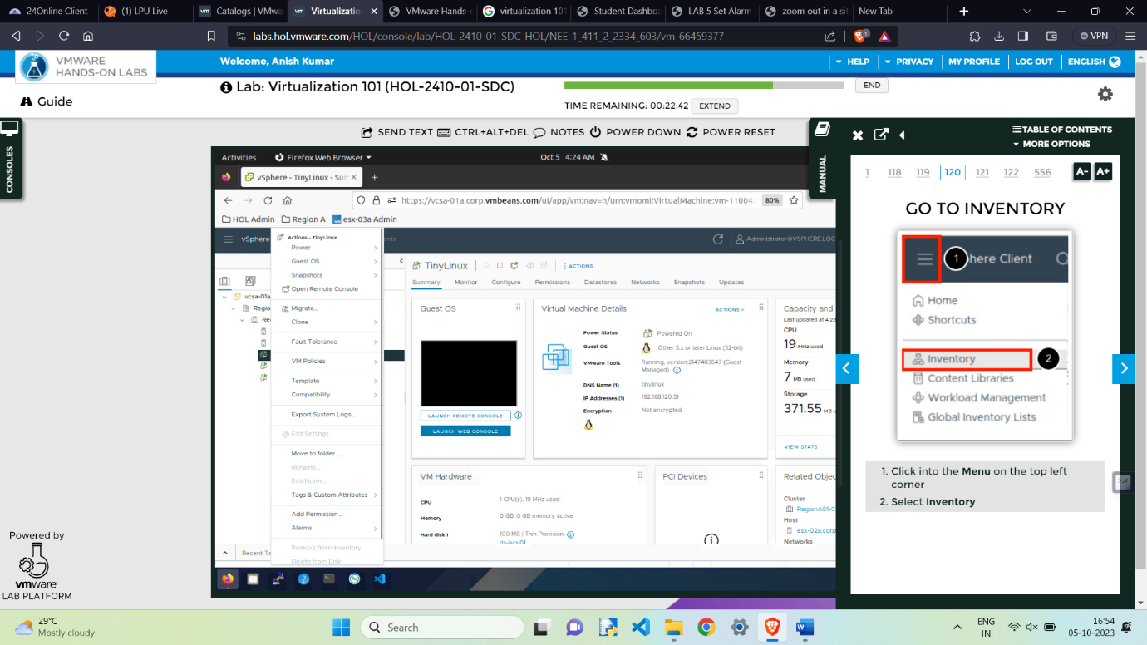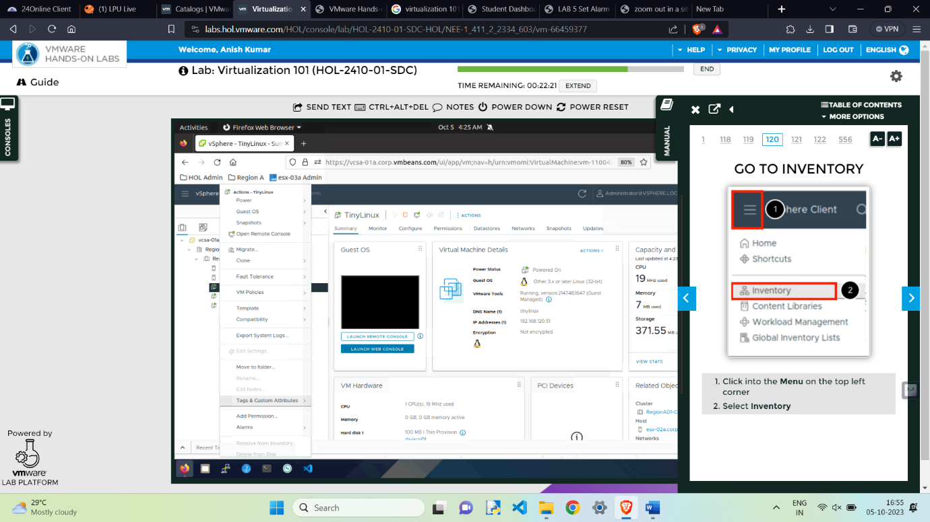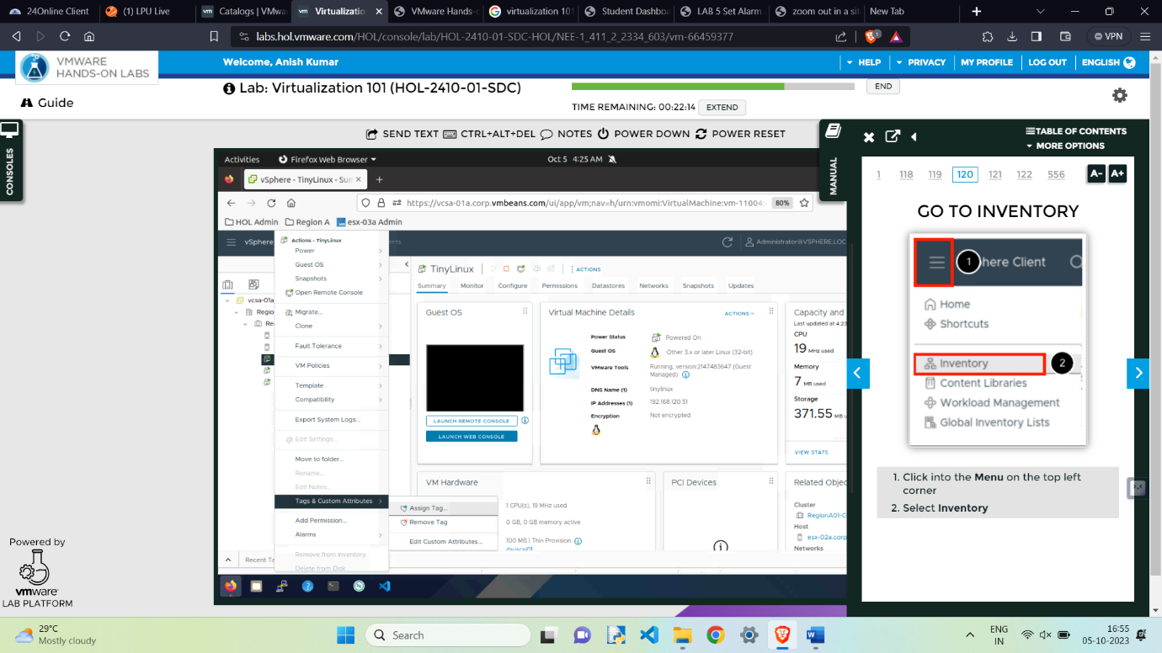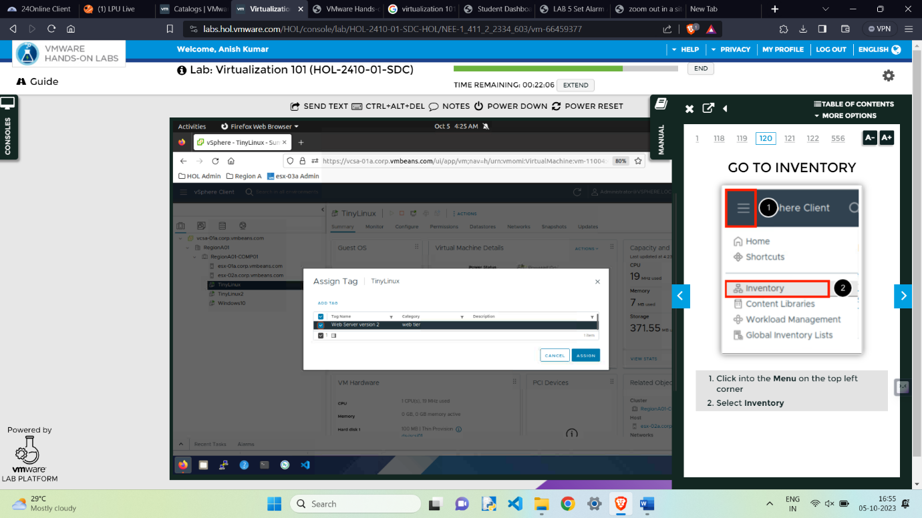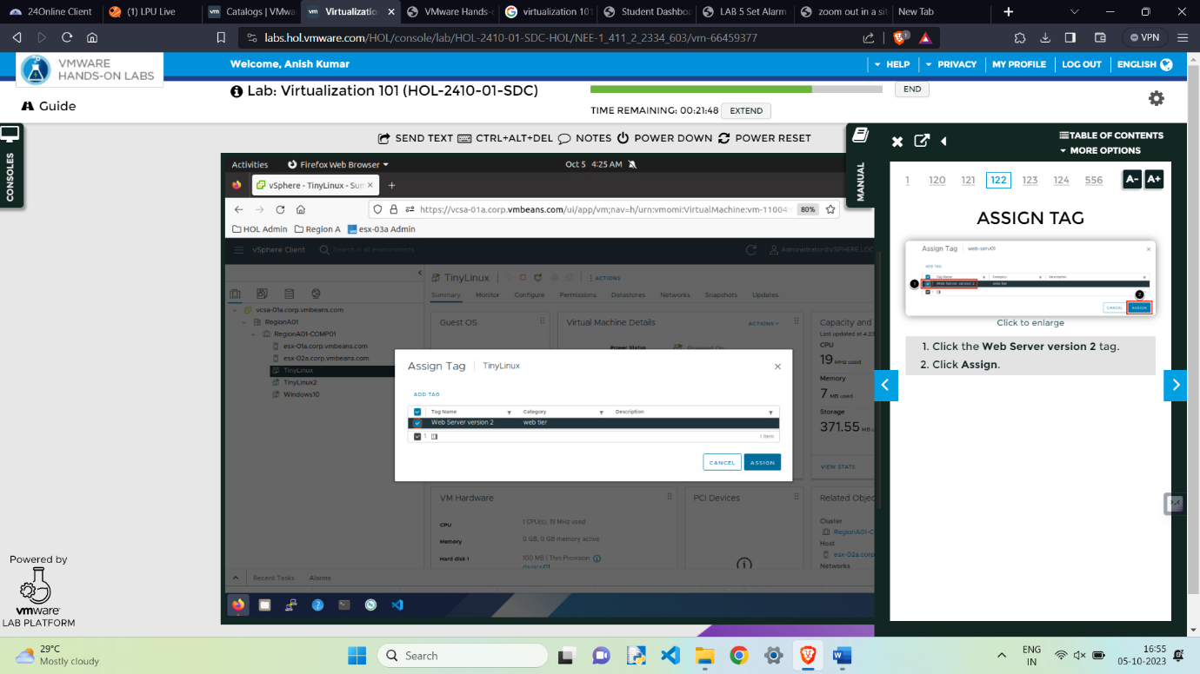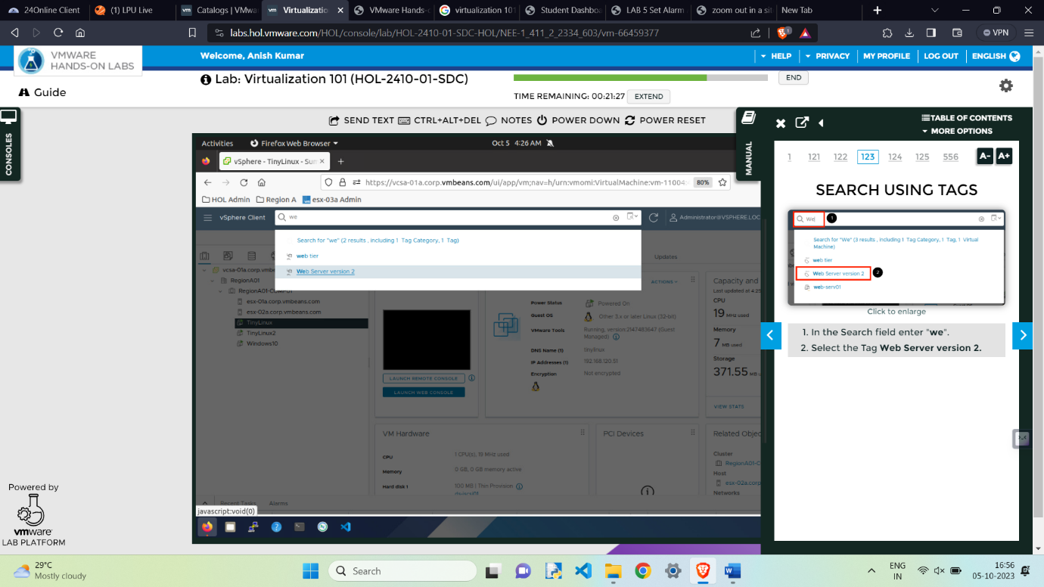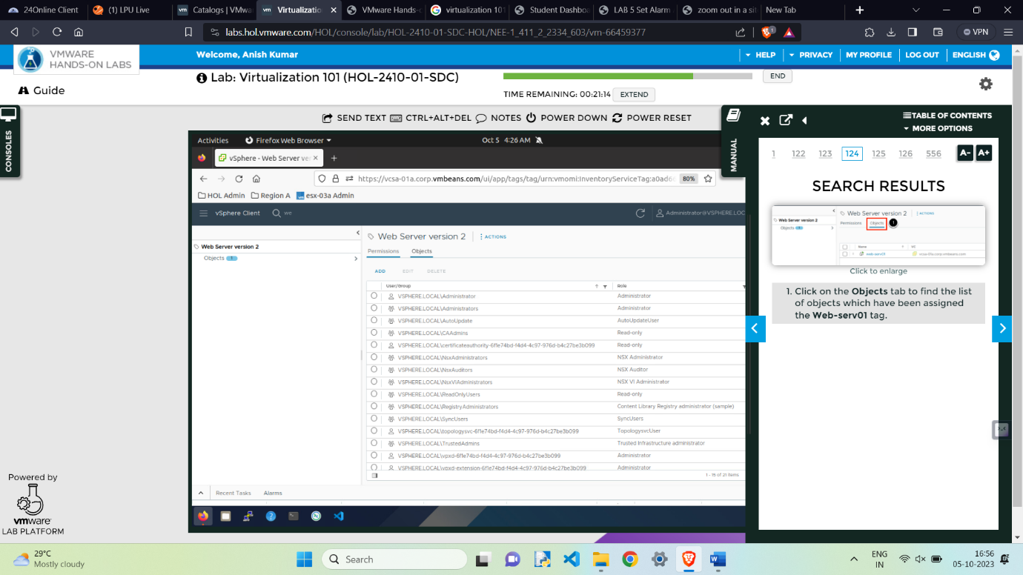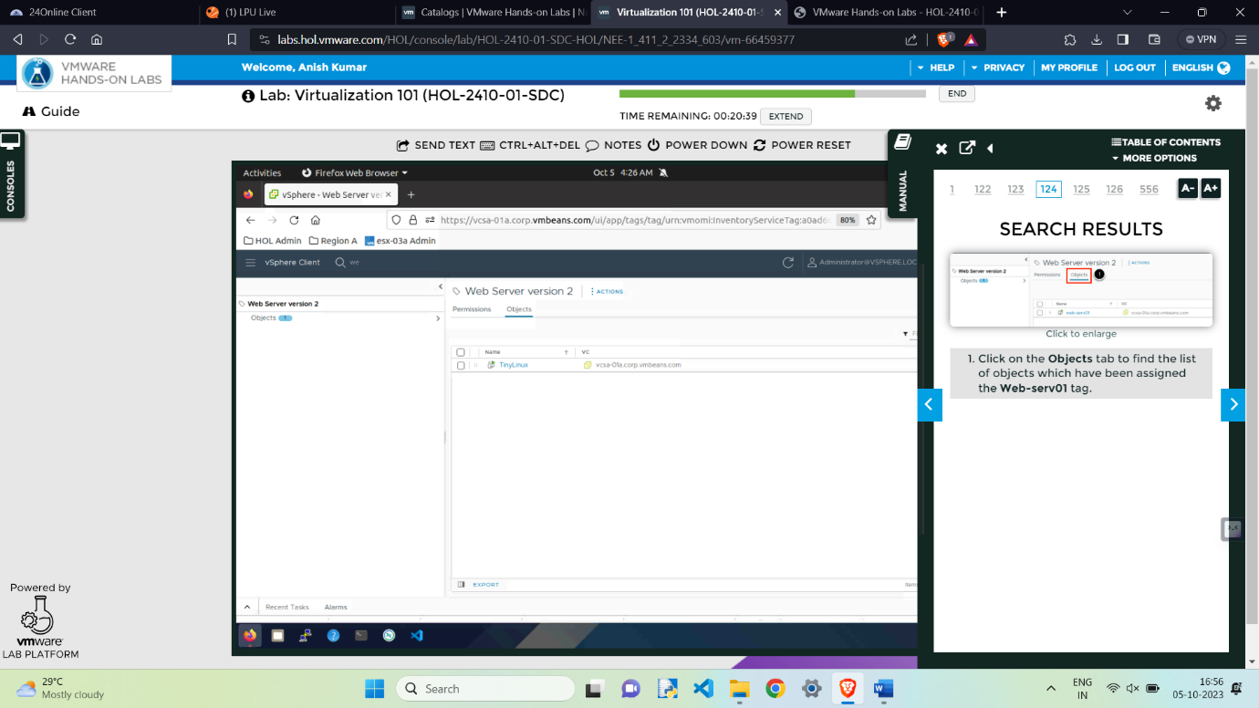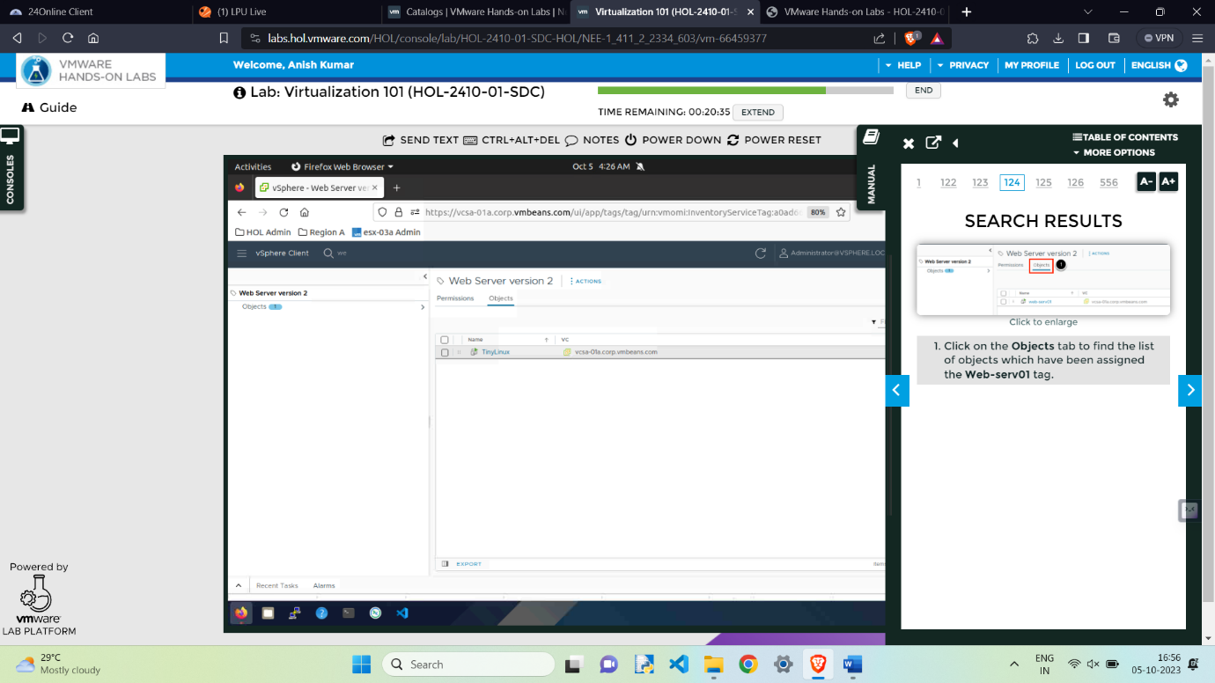

**Searching and tagging both Done.**